Chester Historical Society’s

Chester Historical Society, P.O. Box 376, Chester, NJ 07930 Fall 2007
Web Site: www.HistoricChesterNJ.com ― Email: HistoricChester@gmail.com― Phone: 908-879-2761

Iron Around Us

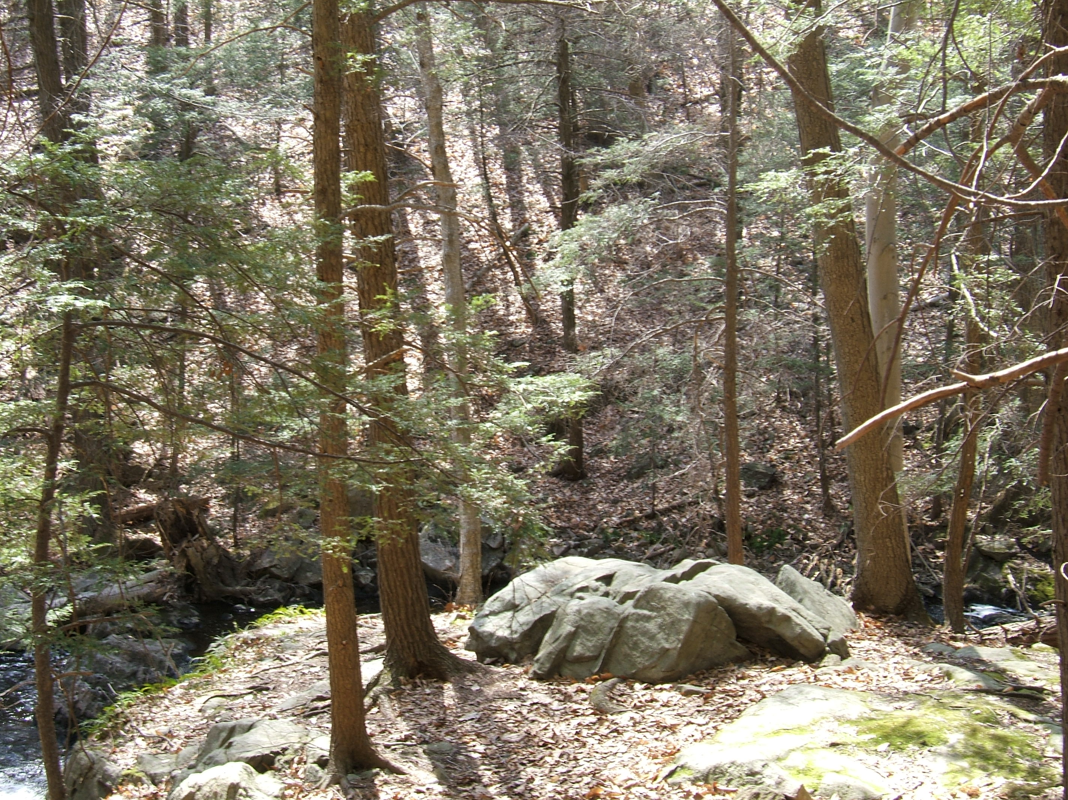
As many people know, there was a time when Chester flourished as a mining town. A walk along our beautiful Black River below the pond on State Park Road will allow you to see the remains of some of the old mines. As you travel the paths, you don’t have to look very hard to find samples of iron ore. See page 6 for the Taylors’s mine-related article.

….Continued on page 2
News & Views Preservation – Information – Education Page 1
News & Views Preservation – Information – Education Page 2

President’s Message
By Carol Zaikowski

November and December are traditionally the time of year when people are scurrying about trying to get a lot of last minute things done: finish cleaning up the leaves, put the gardens to bed for the winter, bring in or tie down anything that doesn’t weather very well, etc. Then it is on to the holidays – buying, cooking, baking, decorating, visiting – EXHAUSTION!! It is a busy time that prepares us for the slow, long days of winter – time to reflect on the past year, give thanks for all our blessings, and plan for the year ahead.

Oh, it can be long, dark and cold – BUT - winter doesn’t have to be boring!

As those long days approach and you are looking for something fun, interesting, and relaxing to do among good company, please keep in mind that the Chester Historical Society welcomes its members to participate in a multitude of challenging endeavors and interesting activities. Think about giving the gift of membership to a friend or family member and bring them along to one of our outstanding programs. We’ve included a Membership Application and Renewal Form on page 7 of this newsletter. We recently had some good, clean, fun learning how to make soap and an informative and spooky night learning about and listening to some local ghosts. There is always something for everyone interested in history.

My sincere “Thank You” to all of our members, for continuing to support the Chester Historical Society through your membership and participation. Special

thanks to those members who have contributed their time and talents to the CHS. Because of your support we continue to be a strong and productive organization.

My very best wishes to everyone for safe and Happy Holidays, and may the New Year 2008 hold good health and well being of mind and body for our CHS members and their families. Peace and God Bless to All.



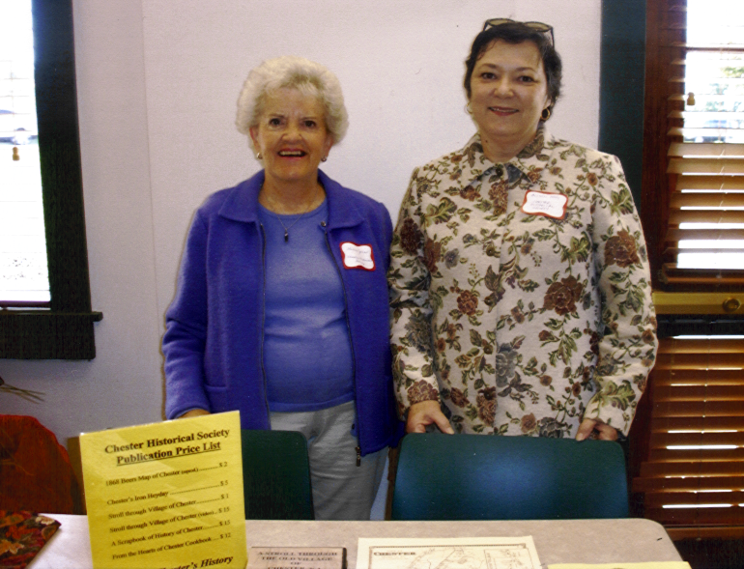
The Chester Library hosted a program on October 13th to welcome newcomers to Chester. The program was designed to introduce our new neighbors to various Borough and Township civic organizations, our police, fire, and first aid departments, several clubs, scouts, and service organizations. Board members Helen Jones and Alison Dahl were on hand to represent the CHS. Thanks to their efforts, the CHS welcomed three new members and sold several of our CHS publications.

Back By Popular Demand
By Alison Dahl, Program Chair

Our October and November programs welcomed back two guest speakers by popular demand. Gordon Ward, who presented his adventure retracing the Lewis and Clark Exploration last year, took us on a ghost hunt just before Halloween this year.

And last year, Jane Chrysostom taught us how American pioneer women made bread and butter. She came back this year and taught us how to make soap from a big bucket of fat, just in time for the winter.

Gordon Ward, lecturer, author and educator who grew up in Bernardsville in a haunted house, scared the daylights out of us with his true facts about what he's seen and heard, and not seen and not heard, about ghosts in this vicinity. Gordon explained that oftentimes, ghost aficionados swear that those bubble-like shadows that show up in photos are spirits. Not so, says Mr. Ward. Rather, they're dust particles, or sometimes condensation on the camera lens that appear in the photos.
Ah, but there are taped recordings of conversations among unseen people, accounts of laughter among unseen children at a long-abandoned one-room schoolhouse site, and screams from a woman whose lover was murdered in the parlor. Bwah hah hah.

Mr. Ward and his ghost hunting colleagues are currently studying The Publick House for any abnormal phenomenon. We've asked him to keep us posted, and if he finds anybody there, to let us be some of the first to know!

Now whoever thought that making soap could be hilarious? Anybody who caught Jane Chrysostom's presentation may think back and laugh again at some of the very funny things she said and did during her lesson on pioneer soap making.

As Ms. Chrysostom explained, some believe that soap originated from the ancient Roman rituals of animal sacrifices on Mount Sapo, from which the word soap is derived. The fats from very fat sacrificial animals (the fatter the better to please the gods) ran down the mountain along with the ashes from the fires and combined to make a substance that made washday surprisingly more successful for those toiling at the foot of Mount Sapo.

The youngsters in our audience were taunted with a large really gross bucket of lard held way too close for inspection, then we were all warned to stay back as very caustic lye was added to the rendered fat. Now this may not seem so funny to those who were not there, but ask anyone who was.

Both Mr. Ward and Ms. Chrysostom are lifelong students of the supernatural and women's pioneer skills, respectively. Their enthusiasm for the subjects was contagious. Speaking of which, we'd love to have you join us for future programs and catch the excitement and learning, usually every second Thursday of the month at 7:00 p.m. at the Chester Library.
News & Views Preservation – Information – Education Page 3

Board of Trustees Meetings

The Chester Historical Society holds Trustee meetings on the first Wednesday of each month, at 7:00 p.m. in the Larison Room of the Chester Library. These meetings are open to all members of the CHS and we encourage you to attend. We welcome ideas and suggestions, and of course we are ALWAYS looking for participation and assistance from the general membership.

Please attend a Trustee meeting and bring along your ideas for helping the CHS to better serve the community!

And Now, the REAL Story
By Carol Zaikowski, President

Historic researchers are often plagued with who, what, where, when, why and how questions, but the most difficult question that crosses a researcher’s path is the question of “IF.” Establishing a place in history relies on all kinds of “IFS” and the biggest problems occur when we have information that has accumulated over time and certainly seems to be historically significant, but we question if it really happened, or if it really happened THAT way.
People love folklore and oral tradition because they put a human touch on events and they often embellish the real facts with the polish that makes them shine through the dryness of names and dates that cause our eyes to glaze over and our minds to wander. Genealogies can be a difficult read with thousands of names and dates over and over again, but those interesting stories printed between the names and dates are what make the information stick. AND, people remember them. I mean, did Great Great Great Uncle Josh REALLY carry a two-ton cow on his back to his hungry family’s soddy through five-foot snowdrifts in a raging blizzard (without shoes, no less) because it was the only food within two hundred miles on that Nebraska prairie? Or is it that the storyteller wanted to convey that Josh was a substantial man, strong of will and body, who loved his family a great deal and provided for them at great cost to his own health and welfare, no matter what challenging circumstances he faced?
George Washington and the cherry tree story was an embellishment on the fact that he is reputed to have been a decent, honest man. We don’t have first-hand knowledge of his character, but the cherry tree story helps to ease his image through the unimaginable horrors of a war that, if it were to be won, demanded a strong and sometimes harsh leader who had to make decisions that might seem reprehensible to many. There are those who somehow still confuse his title of “Father” of our country with the First President’s sleeping everywhere as
General Washington. In fact, he fathered no offspring, but he did love children. And, oh my

gosh, those wooden teeth! If nothing else, he must have been a stoic man!
The question is how do we separate the factual story from the traditional story when entering them into the historic record, and SHOULD we separate them IF they have already become part of the historic record? Chester’s history is full of little embellishments that have actually become a part of our history themselves. I believed the stories about the mob burying bodies in Chester’s iron mines and people getting lost and dying in them until Len Taylor informed me that local farmers told those stories to keep people off of their properties because the mines can be a very dangerous place. Silly me! But I like the “story” better than the truth and IF I still include it as a folklore embellishment when talking about the mines, are people more likely to remember Chester’s mining history? The problem is, how many people did I tell before I knew the REAL story – and – how many people did they tell?

News & Views Preservation – Information – Education Page 4

Archives Report
By Carol Zaikowski

The CHS collection continues to grow and we continue to sort through the boxes and cabinets in preparation for cataloging. If any CHS member would like to help out please get in touch with me and you can choose from many “things to do.”

We have been offered more storage space and hope to be moving much of our collection soon to a new location that is safe, secure, climate controlled, and people and collection friendly. We will have adequate space both in which to store our collection and in which to work and plenty of light, electricity and yes, even running water! As our skills grow in archiving and conserving, we will have room to hold workshops for those members who wish to help out.

To Record Chester’s History,
Record Your Own
By Amanda Dean, Membership Chair

When we talk of history, people usually discuss buildings, monuments, places, a specific happening, such as a war or a revolution. In fact more times than not history is referred to in terms of years ago, old, antique, etc. However history is occurring all around us, every moment. Among the Merriam-Webster’s definitions you will find, “…tale, story, a branch of knowledge that records and explains past events.” It is in the ordinary, everyday happenings of each of our lives that our histories take place and the gradual change of our time is recorded. Most changes do not occur overnight, yet they seem to on paper.
Take a walk on Patriot’s Path along Black River, and try to imagine a train running through where you are walking. For those of you who still get milk delivered to your door, remember the glass bottles? Twenty years ago could you email your children or grandchildren while they were away at college? You probably sent a letter or called. What about the Fourth of July Parade down Main Street? Kid’s today wouldn’t know what you were talking about. How about a family gathering in the living room to listen to a radio program? Now they are watching a flat screen TV with High Def! Imagine a time when candles weren’t accents, but rather a legitimate light source. All of these changes happened over time.
Chester’s history is sewn together by those who live, work and spend time here. Painting today’s history for tomorrow’s generations is of great importance because it will never be as vivid as it is right now. If you sat down to write about your Sunday afternoon, how would you do it? How would we be able to tell when this Sunday occurred, if there was no date on the note. If you wrote, “ I went food shopping

at the A&P,” well, that could have been in Flanders or in Chester depending on the year. What car were you driving - a Hyundai or a Datsun- or where you driving at all? Did you go to the Peach Festival or a craft show? Maybe you stopped by the hardware store- we used to have one. Who were you with and what were the topics of conversation? What was the best selling book at the time? Was Life magazine your choice, or was it People or Consumer Reports? Did you stop a Leck’s for an ice cream cone or did you go to Dairy Queen?
So many things have changed, yet so many things are the same. Yet to make the comparison, you need past information in many forms. Help record our history as it happens, by recording your own. Whether it is a note, a journal, newspaper clippings, photos or stories, whatever details you would like to contribute, so that we may continue to develop our Chester scrapbook of history.

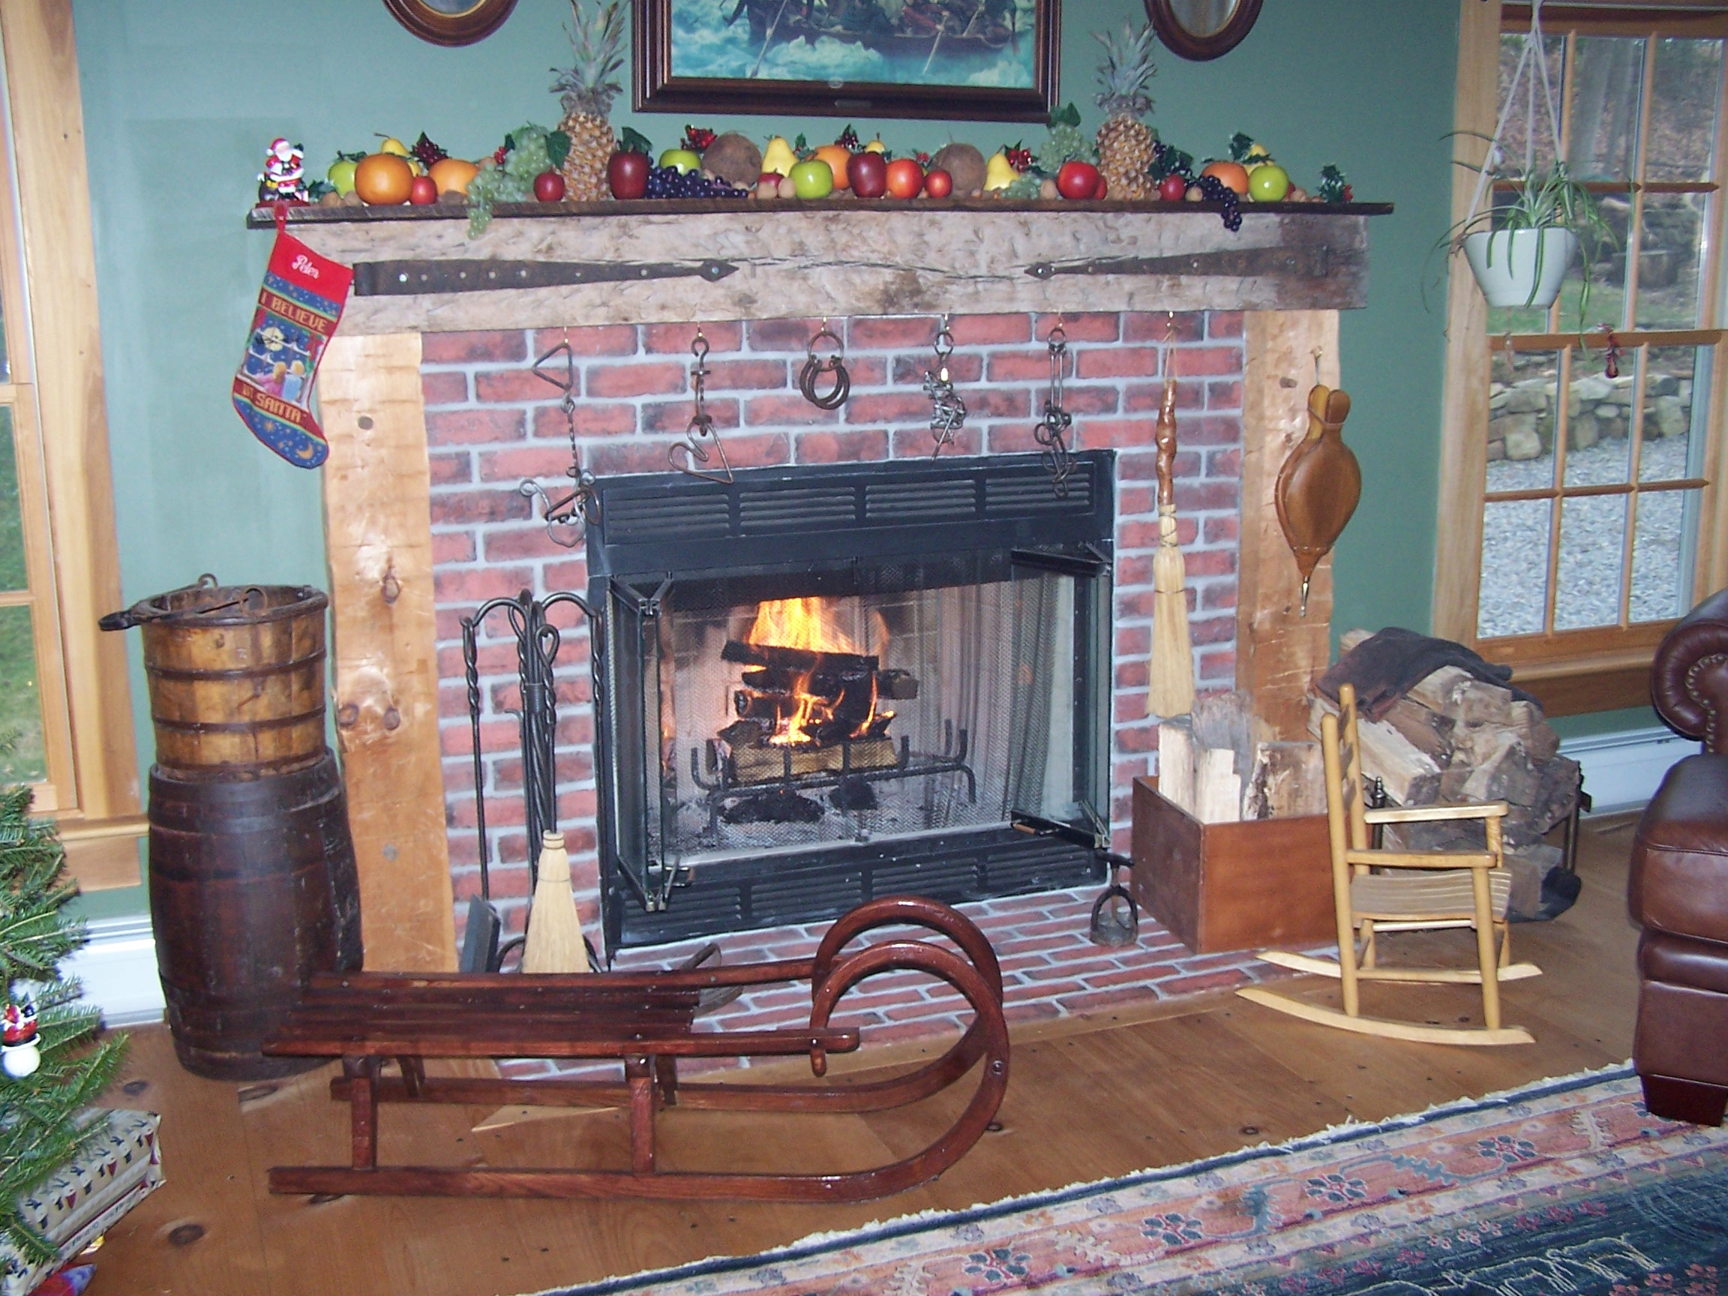

News & Views Preservation – Information – Education Page 5

CALLING ALL MEMBERS!

The Chester Food Pantry needs our help! During this holiday season, your donations are especially needed. Please help us to help those in need of assistance.

The following items are much needed:

Boxes of Instant Hot Cereal
Canned Fruit – There’s a great need for this!

Reminder—The Food Pantry’s drop- off areas are in the foyer of the Chester Library and in the exit area of Shop Rite. The box in the Chester Post Office is for the Morristown Pantry.

Many thanks,
Lois Taylor

News & Views Preservation – Information – Education Page 6

Chester Is Full Of Holes
By Lois and Len Taylor

It was interesting to read in a recent newspaper that Mine Hill is considering storing over a billion gallons of water in an old mine under the town. Let’s all hope the mine is solid rock and not the usual fractured granite and dirt that lies under most of Morris County. Even still water causes shifts in fractured rock and dirt.
Chester suffers from the same unpredictable collapses of old mines as Mine Hill. The mines themselves were fairly well documented unless the owners were trying to escape paying taxes, but the ventilation shafts were seldom recorded. It is the air shafts that usually collapse without warning, and in places where no mine openings were thought to exist. Air shafts were required every few hundred feet since there was no mechanical ventilation available to the miners in the 1870’s or 1880’s. Chester has had several collapses and has a couple of areas that are probably going to collapse sooner or later.
One mine that has not yet collapsed is the Cromwell mine. It was located behind the buildings on the North side of Main street, in the vicinity of New York Pizza. As the deepest vertical shaft mine in Chester at over 200 feet with a couple of horizontal tunnels working off the main vertical shaft, it must have had at least several air shafts. No collapses yet, but wait a few years.
Then there was the Hedges mine collapse in front of the Puddingstone Inn when it was still Larison’s. There used to be two big trees in front, but one disappeared down a Hedges Mine air shaft collapse! The Hedges mine started as a vertical shaft out behind the Lamp Lighter.
An unknown mine has had two collapses on Oakdale Road. It swallowed the owner’s automobile. The second collapse occurred across Oakdale Road from the same house, and less than twenty years ago. It swallowed a storm sewer project.
The DeCamp mine, whose entrance was near the bottom of South Road, a few hundred

yards from where it separates from North Road, also suffered an airshaft collapse less than twenty years ago. The DeCamp mine ran roughly parallel to and under South road, up the hill towards North Road. The collapse occurred in the front yard of a newer home there…..fortunately just after the owner had left the area to do another yard chore. The builder had run the roof leaders into the old air shaft for easy drainage.
Not as much of a collapse as it was an engineering oversight, the roof of the Woodhull Mine collapsed while Four Seasons was digging for its detention pond. Woodhull was a series of mines on the slope where Four Seasons is, and making sure that the dwellings would stay put was no easy task. Fortunately, an observant neighbor noticed the mine roof breach.
Many, many other collapses have happened in the woods or in areas where they were not an immediate problem. If you live on the upslope or top of a hill in Chester, watch where you walk. Watch where you drain your roof leaders. Watch where you put your septic system. You just never know!

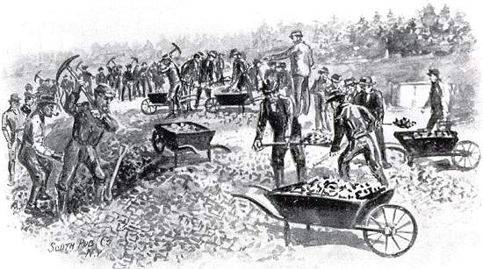

Editor’s Note: To learn more about Chester’s iron mining history, why not purchase a copy of the CHS published book, Chester’s Iron Heyday by Larry Lowenthal!

News & Views Preservation – Information – Education Page 6
News & Views Preservation – Information – Education Page 7

Additional Program News…

We have tentative plans for our next two meetings. On January 10, 2008, we are hoping to a host an "Antiques Show and Tell" modeled after the Antiques Road Show TV program. Members are asked to bring in one or two antique items of interest and we'll have appraisers give an estimate of value and perhaps share what they know about the items. On February 14, 2008, we hope to present the CHS produced program, “A Stroll Through the Old Village of Chester.” We’ll keep you informed, and we hope to see all of you there!

March Program Announcement
By Alison Dahl, Program Chair

On March 13, 2008, Dan Kubert, a CHS member and avid antique toy collector, will present a program about collectible toys. Dan's extensive knowledge of antique toys has bloomed into a lively business that takes him around the country and sometimes abroad, buying and selling treasures.

Reminder: Meetings are held in the Larison room at the Chester Library. They begin at 7:00 PM. Refreshments are provided after the meeting.

Chester Historical Society’s

News & Views

P.O. Box 376, Chester, NJ 07930
(908) 879-2761
HistoricChester@gmail.com
This newsletter is published 4 times a year by the Chester Historical Society.
Editor: Cindy Murphy – (908) 879-1754
Distribution: Brian and Cindy Murphy

Chester Historical Society
P.O. Box 376
Chester, NJ 07930

Membership Application and Renewal Form
(Membership runs from Oct.1 through Sept. 30)

New _____ Renew ____ Today’s Date ___________

Name _______________________________________
Miss, Ms., Mr. First Name Last Name
Mr. And Mrs.

_____________________________________________ Street Address/ PO Box Apt. No

____________________________________________ Town State Zip Code

Age of Children under 18 if applying for Family Membership _________________________________

Email Address ________________________________

Schedule of Annual Membership Dues

Individual….. $8.00/person x No.____= $______
(Individuals over 18 years old)

Associate…...$5.oo/person x No.____= $______
(Individuals 18 and under, or full time students, or those individuals who are 62 or older.)

Family Membership …..$16.00/family x No.____ = $______

Sustaining Membership…..$35.00/each x No._____=$_____

Business Membership…..$35.00/each x No._____=$_____

Life Membership…..$200.00/person x No._____=$_______ (under 62 years of age)

Life Membership…..$100.00/person x No._____=$_______ (62 years of age or older)

Additional Gift ….. $________

Total Enclosed…..$__________

Please let us know if you are interested in serving on one of our committees. Thank you for your support!

Questions? Call Membership Chair Amanda Dean at 908-894-8057 or email amandadean@earthlink.net

Chester

We Need Your Help!



The Chester Historical Society gets occasional inquiries from people doing family and other historical research. Spread the word… maybe you know someone who would enjoy helping others discover their roots! Take a look at the interesting “Geneaology Queries” on our website at www.HistoricChesterNJ.com to view some of the interesting inquiries we have received. We can also use the help of our members to assist with various committees and projects such as going through and organizing our extensive Archives. If you are interested in helping please contact us either by email to HistoricChester@gmail.com or by telephone at 908-879-2761 and leave a message on our answering machine. THANK YOU!

Historical
Society

Elected to Board of Trustees

Carol Zaikowski President
Pam Stevens………………………Vice President
Ed Ng Treasurer
Lois Taylor Corresponding Secretary
Elaine Hanington Recording Secretary
Helen Jones Member-at-Large
Dee Dilley Member-at-Large

Appointed To Board of Trustees

Matt Koppinger Architectural Preservation
Carol Zaikowski…………………………………Archives
Amanda Dean Membership
Helen Jones Oral History
Alison Dahl Programs
Marie Ruzicka Publications
Ed Hanington Borough Historian
Len Taylor………………………..Township Historian

Chester Historical Society
P.O. Box 376
Chester, NJ 07930

Fall 2007

