Chester Historical Society’s

Chester Historical Society, P.O. Box 376, Chester, NJ 07930 Spring 2007
Web Site: www.HistoricChesterNJ.com ― Email: HistoricChester@aol.com ― Phone: 908-879-2761

Another Chester Landmark Back in Business!

Thankfully, new life has been breathed into an old landmark! The Puddingstone Inn recently opened at the former site of Larison’s Turkey Farm. The interior has retained much of its country appeal and the walls are decorated with many curiosities to pique the interest of any history buff. Friends of the Chester Historical Society are encouraged to stop by and try the new menu, which has something that will appeal to just about everyone. We have it on good authority that the Turkey Pot Pie and the Bouillabaisse Pie are delicious!

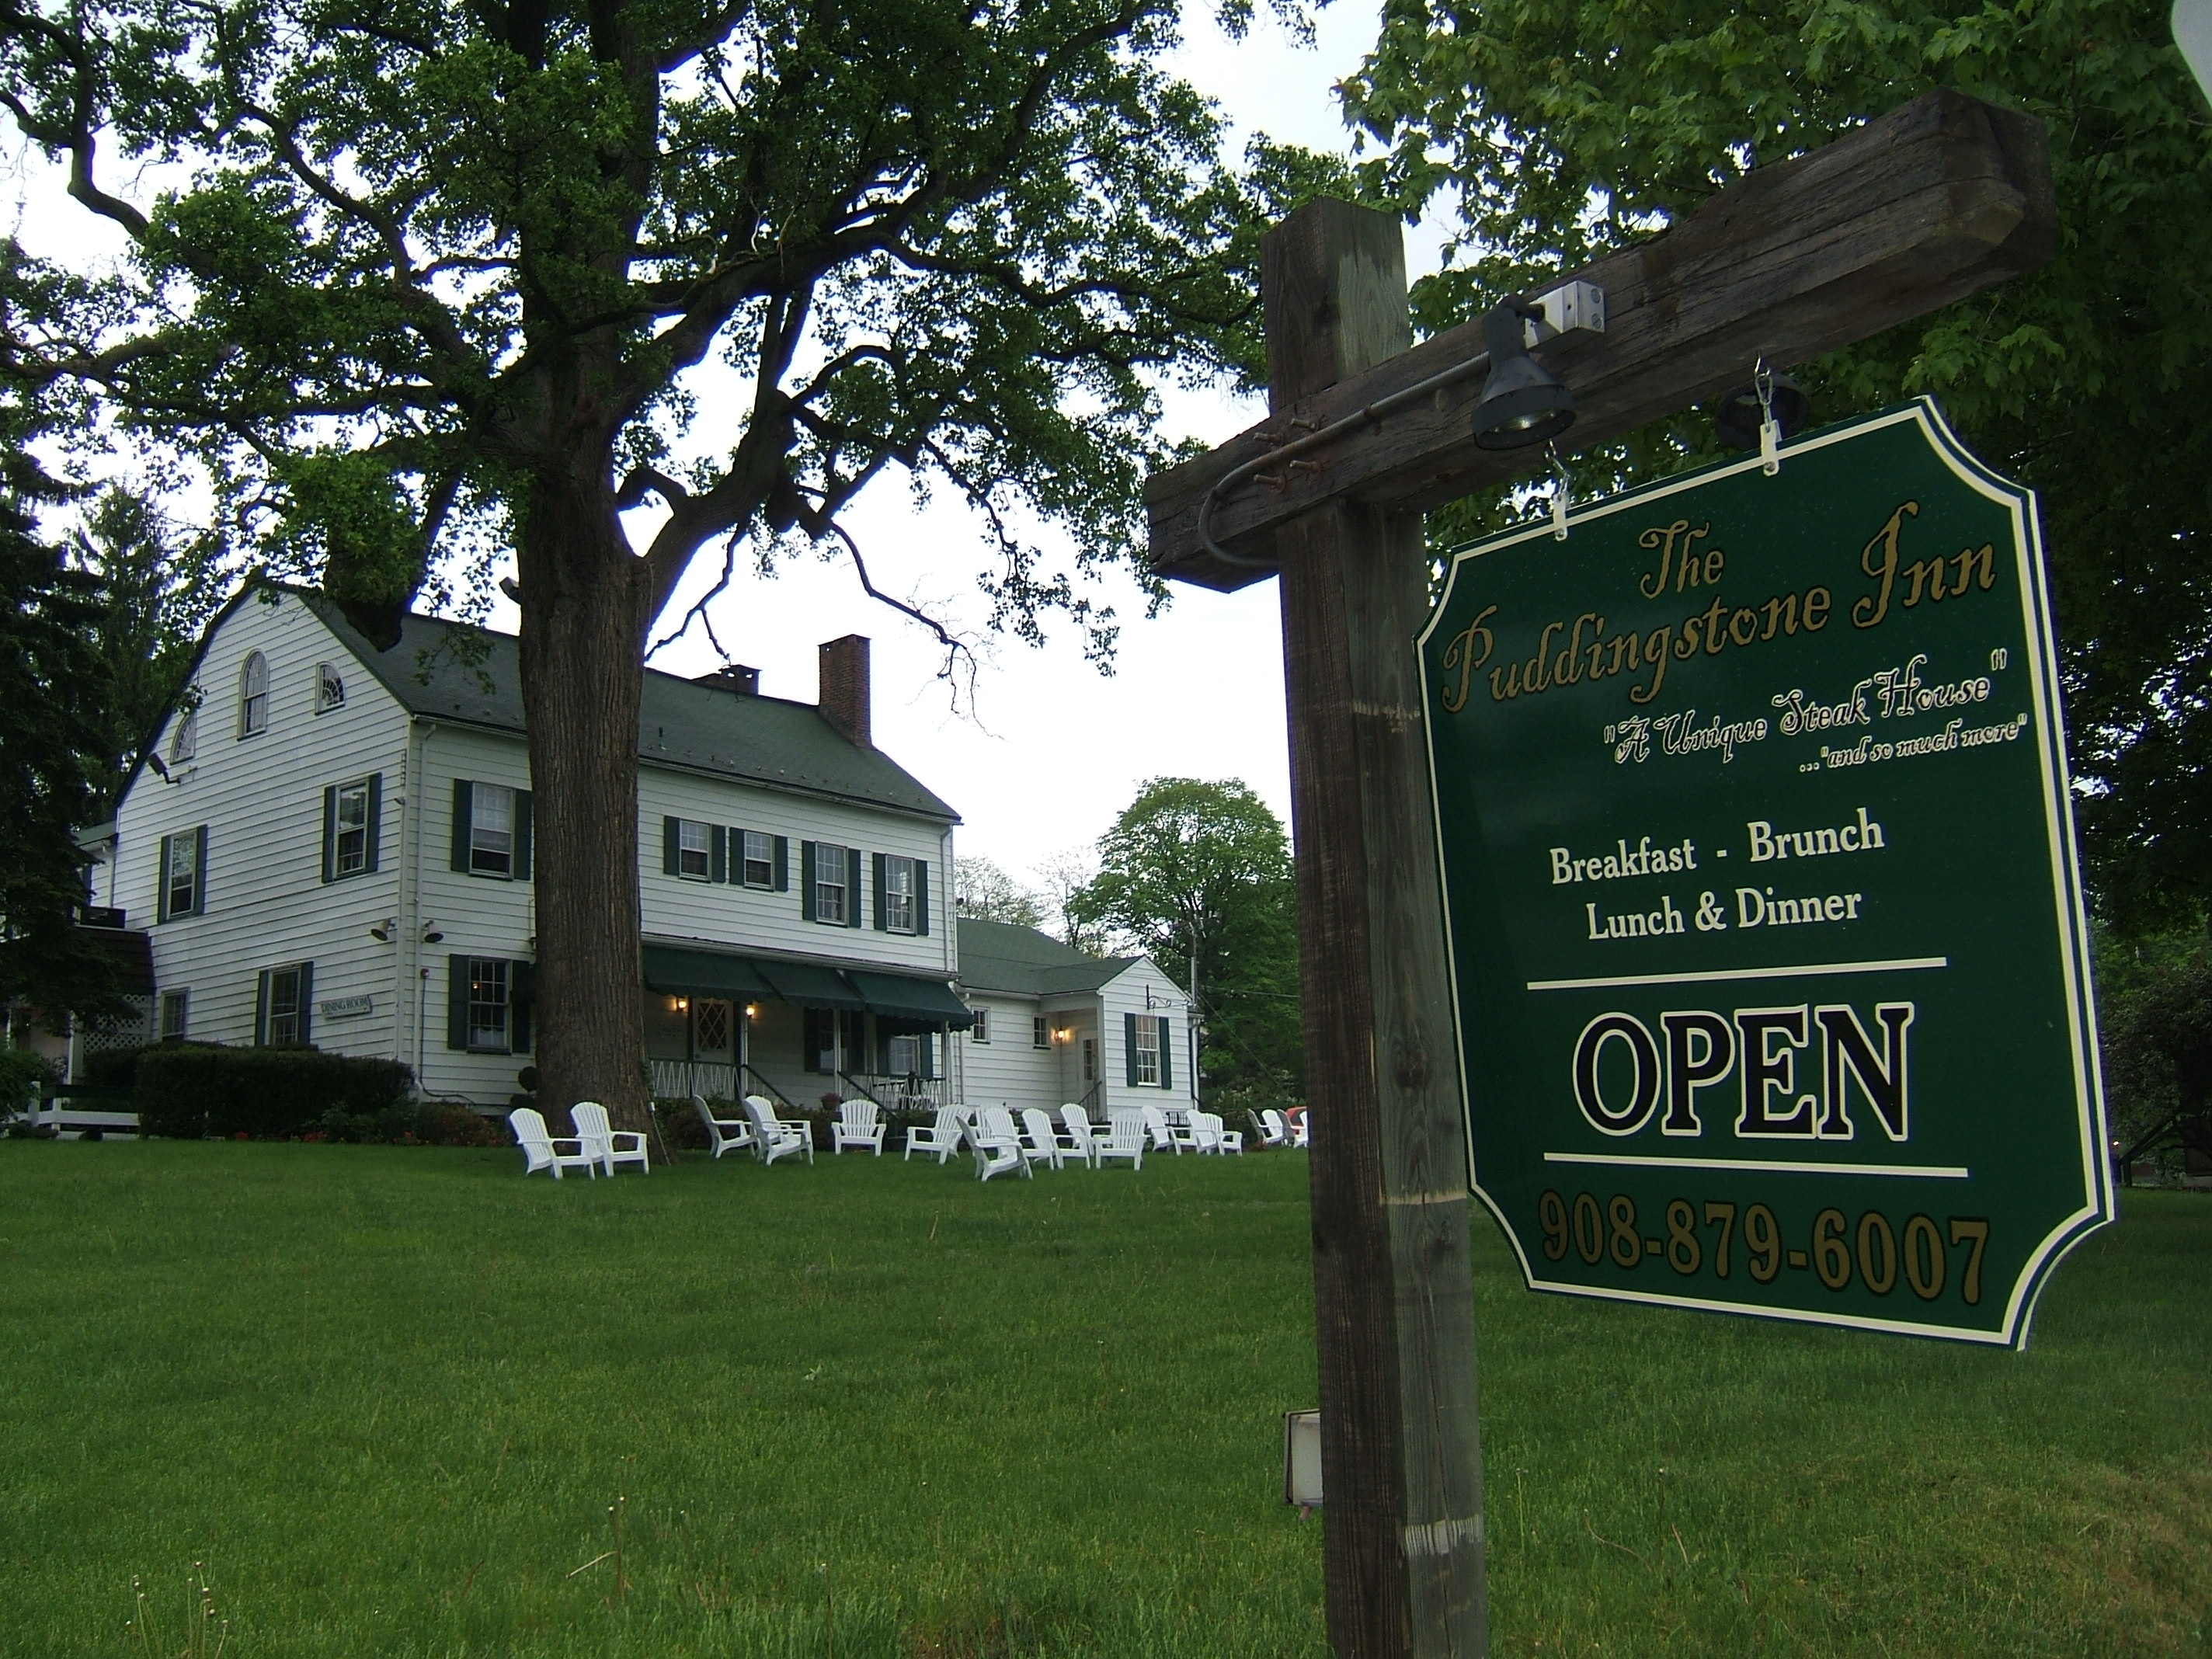

….Continued on page 2
News & Views Preservation – Information – Education Page 1
News & Views Preservation – Information – Education Page 2

President’s Message
Carol Zaikowski

We had a long and sad winter this year, and I think that our sudden jump into spring has reminded us that life does renew itself, spiritually and emotionally, as well as physically.
Carmen Smith’s passing has been such a difficult time for all of us. Having first met Carmen about 25 years ago, I have my own personal memories – Millbrook Village, Indian artifacts and archaeology, digging potatoes, her flower garden, bags of wool, spindles and so much more - which I will always treasure. She prepared us for her illness in her usual, matter-of-fact way, and her own acceptance helped to ease our minds and to move forward, even though our hearts were broken.
We know that Carmen is irreplaceable - and that is as it should be.
Carmen left the CHS an immensely strong foundation on which to continue to build – and she made it absolutely clear to me over her last few months that the CHS needs to push ahead with our work and develop our Society into the organization that she and others had envisioned and had already worked so hard toward - that most of all, we need to accomplish our goals and our mission. I never argued with Carmen’s visions because 1) she was usually right and, 2) it was futile.
Carmen’s daughter, Claire, has sorted through Carmen’s CHS items and has generously donated them to the CHS. Working through her own grief, Claire’s methodical approach and excellent skills in organizing Carmen’s collection before giving it to us has made our job in Archives a little less difficult and she has our heartfelt thanks and appreciation
Carmen’s well-organized files leave almost

nothing to ponder, but I am in awe at the immense amount of research and planning that she accomplished over the years and I continue to learn from her work – all done over the telephone, through personal letters and a lot of leg work, and all done without a computer or email (probably WHY she accomplished so much and kept a good, strong relationship with everyone!). She left handwritten notes on everything she did, and I can hear her voice and see that twinkle in her eye every time I read them.
Such a determined, yet gracious lady and such an unselfish and thoroughly good person, her enthusiasm and dedication continue to be felt in the Carmen Smith History Room, so appropriately named.

Thank you, Carmen, for sharing your love of history and your zeal for life. You taught us well and we are so very grateful.

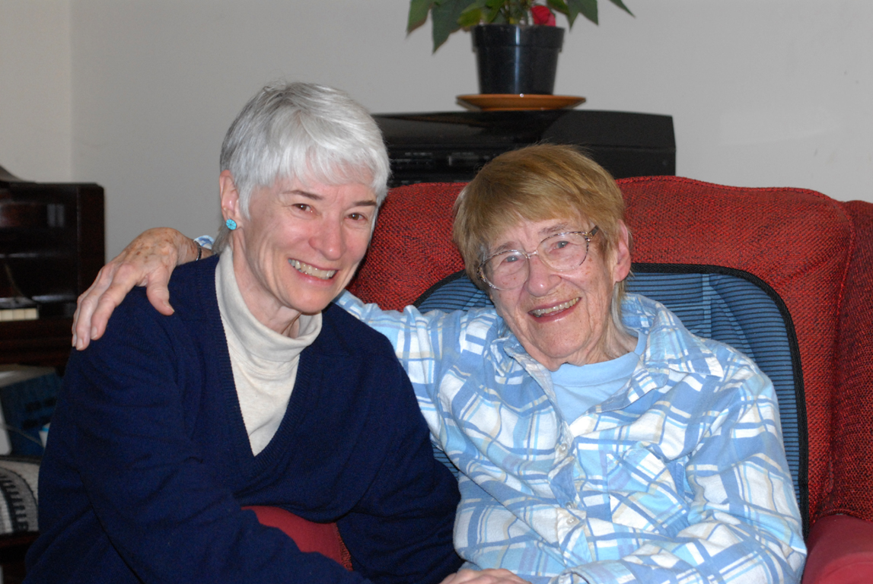
Carmen Smith is seen here with her daughter, Claire Smith Hanson. Photo by Joan Case.

News & Views Preservation – Information – Education Page 3
Which Is It,
Black River or Lamington River?
By Brian Murphy

I have a map book published in 2001 called the New Jersey Atlas & Gazetteer. On page 30, the map that shows Chester, calls the river flowing through the Black River Wildlife Management Area the “Lamington River.” This obvious contradiction encouraged me to try to find out more about the origin of these two names for our river.
Prior to the arrival of the Europeans, the Indians who lived and traveled through this part of the country had their own names to describe the features of the land. The early Europeans who surveyed and settled in the Chester area encountered these natives and learned many of the local place names from them. John Reading Jr., an early explorer of Morris County, kept a log of his travels and described many of the places he visited by their Indian names. “Papeck” (Peapack) and “Whippaning” (Whippany) are two examples that are still in use today. I have seen more than one early New Jersey land deed that actually credits the names of certain places to the Indians.
One of the names for the river that runs through Chester is derived from an Indian dialect. It probably sounded something like “allamatunk” to the settlers who first heard it. “Lamington” is the modern English form of this Indian word or phrase. It’s fascinating to compare early maps of our area to see the different variations of these names. There is a true copy of a map made for the great American Revolutionary War General Nathanael Greene in the collection of the Somerset County Historical Society. The map, which was made in 1777, shows our river emptying into the North Branch of the Raritan River and is described as “A Branch of Raritan called Allamting.” Of course the British Army employed their own mapmakers during the war and Lieutenant John Hills of the 23rd Regiment drew several maps of the New Jersey countryside, one of Somerset County in partic-

ular. This 1781 map shows the “Lemeton Fall” just barely inside the Morris County line on the “Lemeton River.” Without a doubt, the mapmaker was indicating the falls at Pottersville on the Lamington River. Lieutenant Hills drew another map that same year of Northern New Jersey, but this time he calls our river the “Black River,” and he calls a mill on the river “Lamatonk.” The map locates the mill not too far from New Germantown (modern day Oldwick) and almost precisely where one would expect to see the village of Lamington.
Since the original meaning of “allamatunk” is open to speculation, I’ll share some of the theories that make the most sense to me. Perhaps “allamatunk” was the name the Lenape gave to our branch of the Raritan River, or maybe it was their name for a major feature of the river like the falls at Pottersville. I am sure the Indians had names for their trails. “Allamatunk” could have been their name for a trail that the late New Jersey State Archaeologist Dorothy Cross says passed through Pottersville and ran from the Delaware Water Gap to New Brunswick. I have read in some places that “allamatunk” translates into something like “black earth bottom,” or “black rock bottom,” but none of the Indian to English dictionaries that I have seen confirms this. I think it is more likely that the name “Black River” is just the descriptive name the early settlers gave to the river, rather than a translation of the Indian name. But I could be wrong.
There is a wonderful manuscript land deed from the year 1738 in the possession of the Chester Historical Society. (Next time you are at the Chester Library, you can see a copy of it hanging on the wall in the Carmen Smith History Room.) In the text of the deed it describes the river in Chester as, “…the abovesaid black river or Lamenton river.” This document shows that calling our river by two different names is a tradition that goes back at least 269 years. So take your pick.

Halleluiah! We Have Recreation!
By Lois and Len Taylor

In 1968, there were no real facilities for organized recreation in either Chester. Who needed it? You played in the woods, hiked the paths, road your bike without fear of cars and played ball either at the Borough Field or one of the two schools. BRMS wasn’t there and Williamson was closed. You went swimming or skating at a swampy pond, the Black River or at Chester Springs, which was a private swimming hole with a diving board right where the Burger King building is now. Mostly you just made your own recreation or went out of town.
The coming of Melrose Village in the early 60’s changed all of that. Melrose was the beginning of build-out and many people who came from the “city” expected municipal recreational facilities. The reluctance of either government to get involved was astounding. You heard, “too expensive, too ambitious, too much liability, no space, who needs it?” and a myriad of other reasons. So was born the Chester Recreation Club.
“The Club” was a group of about eight Borough and Township residents who each chipped in a few dollars with the intent of buying twenty-three acres on Lamerson Road. The layout called for an Olympic sized pool, three baseball fields, two soccer fields, tennis courts and a large pavilion with lavatories. The whole project would be sponsored by private membership. Just when “the Club” was about to close on the property, the Township Mayor had an epiphany and spearheaded the purchase of forty acres on Furnace Road “for recreational purposes.” The real reason for the purchase was so that the Township could avoid the huge embarrassment of being upstaged by a rag-tag private group.
It was a good purchase, though, because it wasn’t long before the Chubbs donated Chubb park next to the forty acres and eight private citizens avoided a huge responsibility and very
large debt for a project that may or may not have actually reached fruition.

Thirty years and multiple studies later, the Chesters finally got a pool. And, guess what?
The pool impetus came from a group of private citizens and a dedicated teacher named June Hinds who left a quarter of a million dollars to get the pool started. June knew of the old inertia and left a will that said essentially, “Use it or it goes to my nephews and nieces.” June was a long time and valued friend of the writers, who enjoyed every minute of her acerbic sense of humor.
There are tennis courts now, four in all. There are soccer fields, baseball fields, a skating pond, a couple of kiddie parks, woodland trails, lavatories and the pool. There is also the hallmark of recreational facilities, a concession stand. All started from eight residents, a Mayor avoiding embarrassment and June Hinds.

Who would have thought?

News & Views Preservation – Information – Education Page 4

Life Atop Schooley’s Mountain
By Alison Dahl, Program Chairman

Our May program featured George Scheller, who grew up and still lives on the top of Schooley's Mountain -- for more than 75 years. Mr. Scheller wove a story that began with the areas heydays (well before his arrival) when it was a mecca for the rich and famous who sought the rejuvenating powers of the mountain's spring waters.
As a child, he recalled being one of the six children who lived on the mountaintop. In the wintertime, after a good snowfall, they'd sled all the way down Schooley's Mountain almost to Hackettstown. The trudge back up the mountain was daunting, but well worth the ride down again.
Mr. Scheller brought along several aerial photos of the local landscape he took in the early 1950s, attesting to how sparsely settled it was. To take

…See Life, page 5

See

Archives
Carol Zaikowski, Archives Chair

As those HOT and STEAMY summer days quickly approach, think about cooling off in the air-conditioned Chester Library! Bring your headphones, cool down and chill out all while you’re sorting through Chester’s history.
The Carmen Smith History Room is bursting at the seams with boxes and boxes of material (the “stuff” that history is made from OR the “stuff” which history has made). I greatly appreciate the help from the volunteers who have already started – Elaine Hanington, Matt Koppinger and Pat Middings – and who have made the time to sort through this material. It hasn’t always been fun, it definitely has not been clean fun, but it has been somewhat exciting AND surprising at times. We have about a dozen people who have signed on to help out and who have attended an information session. I am looking forward to getting this phase of the project done, and DONE it will get! We can always use more volunteers, so if you have some free time, give me a call (876-9599) and I’ll be happy to meet you at the Chester Library.
Thank you Helen Jones for going with me to the BARN to look for the rest of the oral history files (which we found, among other things). Helen has been busy sifting through and organizing the oral history data and tapes and researching more efficient and permanent ways to save this precious information.
It is always an adventure when you go to the barn. Guided tours are free for CHS volunteers.
In the meantime, there are many things in the History Room that need to be done including: 1) A list and description of the publications that we already have on the shelves is needed so that it is easier for visitors to see what we have and find what they are looking for. 2) A notebook identifying and describing those items that are displayed in the History Room (mostly on the walls) should be compiled for use by Library Staff, CHS Volunteers and for visitors. Anyone who can do this, please call me.
Make sure that you take the time to catch the exhibit of the Cooper sword, sash, and photograph that Matt Koppinger is putting

together in the Bob Smith display case in the Library.

AND watch for an announcement regarding the BARN. Coming soon!!!

Nothing is more precious to our knowledge of history than those who are willing to work toward preserving it. Thank you all.

Many hands. . . . .

News & Views Preservation – Information – Education Page 5
…Life, Continued from page 4

the photos, a plane picked him up at an 1,800 foot landing strip that was on a plateau on the mountain. The airstrip was near where Thomas Edison owned a hunting lodge and land that was also used as a location for many early movies.
Mr. Scheller's enthusiasm for the history and his life's experiences growing up and raising his family on the mountain was contagious. He wrapped up his fascinating recollections by saying, "I love Schooley's Mountain," and the audience applauded in acknowledgement and appreciation. Thank you for sharing these memories with us, George Scheller.

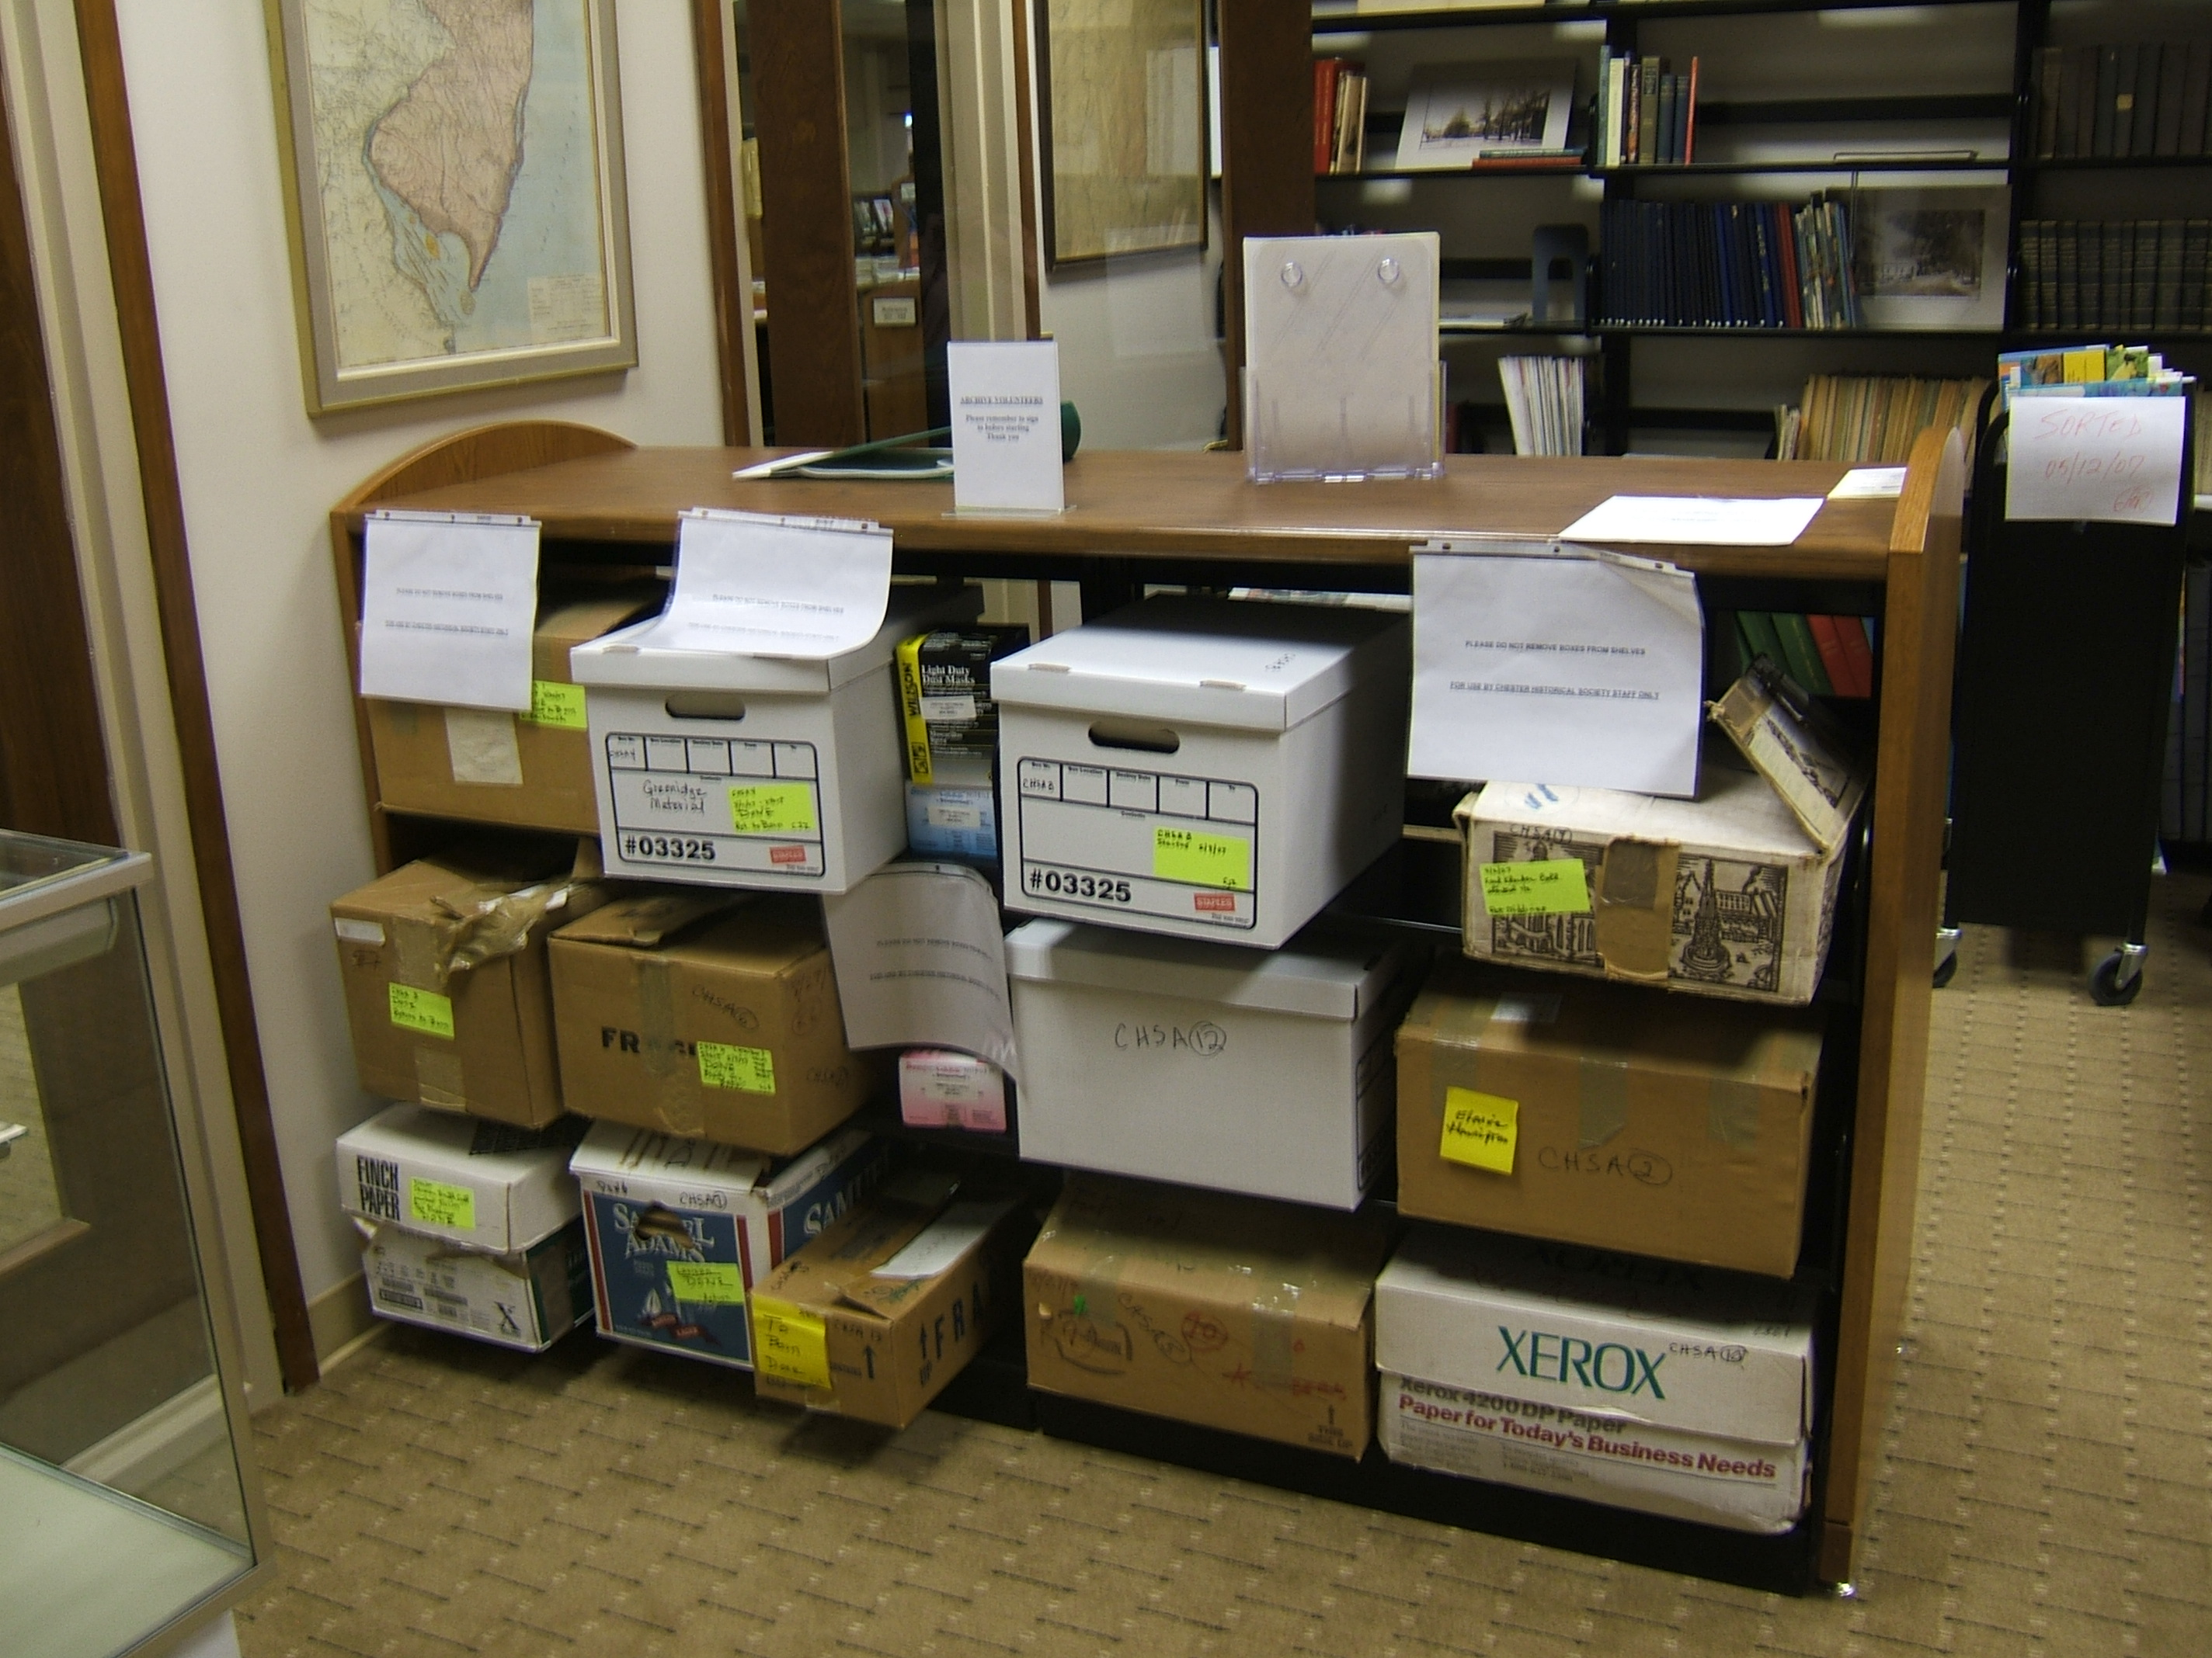
This is just a small sampling of the boxes from the barn. Some have already been sorted, but there are many more to go through! Please help us rediscover the treasures the CHS has collected over the years. You never know what you might find!

Wednesday, July 4, 2007
12:00pm-4:00pm
Flag of Freedom
Meet "Uncle Sam" and discover how Thomas Nast created this well-known political character.
Saturday, July 7-Sunday, July 8, 2007
12:00pm-4:00pm
Time Warp
Explore military camp from the French and Indian War through the Civil War era.
Sunday, July 22, 2007
1:00pm
Miller's Pancake
This program revolves around Eric Carle's book Pancakes, Pancakes! It starts by explaining where the flour comes from and then participants help to make a perfect golden brown pancake. Yum!

Saturday, July 28, 2007
1:00pm-4:00pm
Woolen Critters
Try your hand at wet-felting. You’ll start by making small balls, but by the end you’ll get to create animals and other small objects.

Sunday, July 29, 2007
12:00pm-3:30pm
Flour Power
Tour the mill to see how its machinery grinds grains into flour. Find out how much flour the mill can produce in one day.

Summer Fun at the Cooper Mill

Throughout the summer you can find a wide variety of activities for all ages to enjoy throughout Morris County. Here is just a small sampling of upcoming events at our own Cooper Mill. Be sure to investigate happenings at other Morris County treasures such as Fosterfield’s and Historic Speedwell.

Saturday, June 2, 2007
1:00pm-4:00pm
"Common Thread" Quilters
Enjoy a demonstration of quilting by the "Common Thread" Quilters and see a beautiful quilt exhibit.

Saturday, June 9, 2007
1:00pm-4:00pm
Lifeways with Lenape
Guest speaker, John Kraft, will discuss the native heritage of this area and the development of the Lenape Woodland Culture. Take part Native American games and other activities.
Pre-registration required at 973-879-5463.

Sunday, June 17, 2007
1:00pm-4:00pm
Men of Steel
Blacksmith Kevin Perry will forge steel into works of art using early 19th century techniques. Dads receive a FREE bag of flour or cornmeal.

Saturday, June 23, 2007
11:00am-3:30pm
Flour Power
Watch the Fitz waterwheel use the power of the Black River. Find out how much flour the mill can produce in one day.

Sunday, June 24, 2007
1:00pm-4:00pm
A Tisket...A Tasket...She'll Weave a Basket
Guest crafter, Elissa Kessler-Caporale demonstrates basket weaving techniques. Make and take home a woven bracelet.

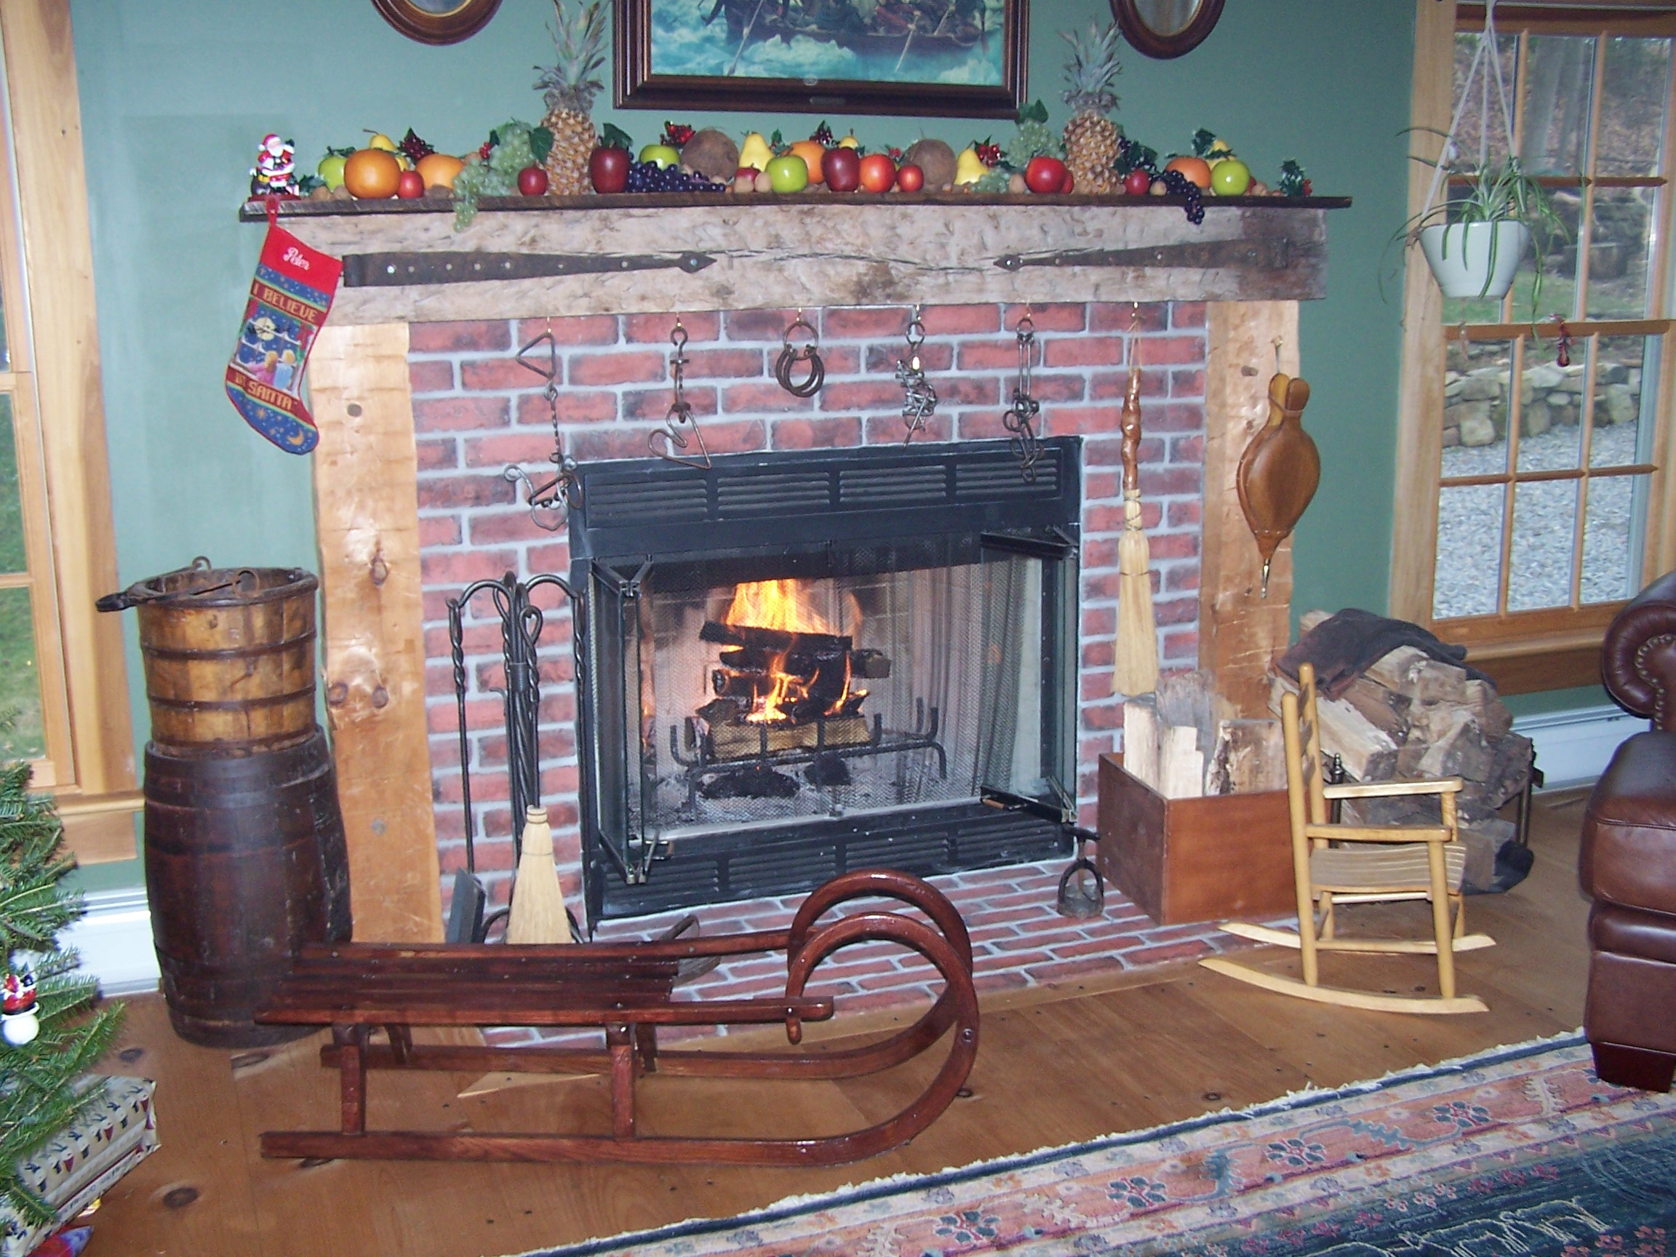

News & Views Preservation – Information – Education Page 6

CALLING ALL MEMBERS!

The Chester Food Pantry needs our help! The following items are especially needed:

Canned fruit
Pasta Sauce

Reminder—The Food Pantry’s drop- off areas are in the foyer of the Chester Library and in the exit area of Shop Rite. The box in the Chester Post Office is for the Morristown Pantry.

Many thanks,
Lois Taylor

Daniel Skellinger: Revolutionary War Soldier from Chester
By Brian Murphy

During the Revolutionary War, all able bodied men between the ages of 16 and 50 were expected to enlist in the local armed militias. About thirty-five men from Chester served in the Morris County Militia and helped play a vital role in the struggle for American Independence. As fate would have it, New Jersey was geographically sandwiched between the capital of the British Army at New York and the “rebel” capital at Philadelphia. Not surprisingly, more fighting took place in New Jersey than in any other state during the war. As a result there was little rest for many of the militia units in New Jersey during the eight year-long war.
In 1832 Congress passed a liberal service-pension law, which extended compensation for service during the Revolution to members of the militia and their families. By this time, veterans of the revolution were quite old. In order to receive a pension the applicant had to prove that they had served during the war and that they met the requirements set forth by Congress. The surviving veterans or their dependents brought forth sworn testimony of their war records, which was forwarded to Washington, DC for approval.
Dr. Lewis Condict of Morristown recorded many of the sworn statements about the war service of local veterans. Daniel Skellinger of Chester was 77 years old when he applied for the pension in July of 1834. Dr Condict’s abstract of Skellinger’s activity during the war, reveals that he was a typical militia man in the sense that he served on a rotating basis, spending about a month on duty, then a month off at home, then back out again. After volunteering in 1776, his first assignment led him to march with his unit from Chester to Long Island where he was present during the ill-fated Battle of Long Island. Much of Private Skellinger’s time in the service was spent on “guard duty” at Elizabeth. Skellinger

and his fellow soldiers who were stationed there were the first line of defense in the event that the British Army advanced on New Jersey from their Headquarters at New York. This was often a concern, particularly when General Washington made his headquarters in Morristown. Private Skellinger served at various times in the companies of Captains Luse, Horton and Terry, all officers from the Chester area. In 1779 Skellinger accompanied the militia when they were sent to pursue the Indians and Tories who had pillaged and burned the Minnisink settlement on the upper Delaware. In 1780 he was with his unit in the vicinity of Connecticut Farms and Springfield where the last battles in the North were fought during the war.

News & Views Preservation – Information – Education Page 7

Chester Historical Society’s

News & Views

P.O. Box 376, Chester, NJ 07930
(908) 879-2761
HistoricChester@aol.com
This newsletter is published 4 times a year by
the Chester Historical Society.
Editor: Cindy Murphy – (908) 879-1754
Distribution: Brian and Cindy Murphy

Members Welcome

The Chester Historical Society holds Trustee meetings on the first Wednesday of each month, at 7:00 p.m. in the Larison Room of the Chester Library. These meetings are open to all members of the CHS, and we encourage you to attend. We welcome ideas and suggestions, and of course we are ALWAYS looking for participation from the general membership.

Please attend a Trustee meeting and bring along your ideas for helping the CHS to better serve the community!

Chester

Summer Picnic Reminder

The Date—August 19th
The Time— Noon
The Place-- Cooper Mill Carriage House

Please join us for this (members only) summertime tradition. Once again we’ll enjoy live bluegrass thanks to the talented group "Monday Night Jam." Be thinking of a side dish or dessert to bring along to share. It is also important to note that we will be electing a Vice President, Corresponding Secretary, and Treasurer. You will be receiving an official invitation by mail. Please respond if you are going to attend!

Upcoming Program Reminders

September 13th – To Be Announced
October 11th - "Ghosts at Our Doorsteps"
November 8th - "Homesteading 101: Soap Making"

Reminder: Meetings are held in the Larison room at the Chester Library. They begin at 7:00 PM. Refreshments are provided after the meeting.

Historical
Society
(Terms Beginning Oct. 1, 2006)
Elected to Board of Trustees

Carol Zaikowski President
Ed Ng Treasurer
Lois Taylor Corresponding Secretary
Elaine Hanington Recording Secretary
Helen Jones Member-at-Large
Dee Dilley Member-at-Large

Appointed To Board of Trustees

Matt Koppinger Architectural Preservation
Merry Morton Historic Sites
Amanda Dean Membership
Jackie Wachsmuth Oral History
Alison Dahl Programs
Marie Ruzicka Publications
Ed Hanington Borough Historian
Len Taylor Township Historian

Chester Historical Society
P.O. Box 376
Chester, NJ 07930

Spring 2007

