Chester Historical Society’s

Chester Historical Society, P.O. Box 376, Chester, NJ 07930 Summer 2006
Web Site: www.HistoricChesterNJ.com ― Email: HistoricChester@aol.com ― Phone: 908-879-2761

The Rain Stayed Away !
By Alison Dahl

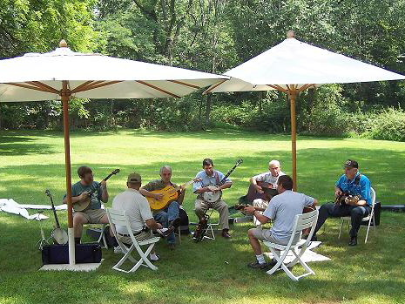
Monday Night Jam entertained our members at the annual picnic at Cooper Mill. Photo by Joan Case

It was touch and go weather-wise but we lucked out with a warm, humid, mostly cloudy day for our annual picnic at the Cooper Mill Carriage House on August 20th.
Picnic-goers were welcomed to the festivities by the lively, toe tapping bluegrass tunes of Monday Night Jam, Steve Zaikowski's band. Steve is the husband of our new President, Carol Zaikowski. The bluegrass music provided a delightful background to the day, and we express our thanks to all of the great musicians for making the picnic a truly special event.
As the crowd settled, outgoing President Joan Case opened the annual business meeting. Highlights of the business meeting included the election of officers, a presentation of a thank you gift to Joan for her hard work over the past four years as President, and the presentation of the Architectural Merit Awards.

…See Picnic, page 5

….Continued on page 2

News & Views Preservation – Information – Education Page 1
News & Views Preservation – Information – Education Page 2

Outgoing President’s Message

It has been my pleasure to serve as the President of the Chester Historical Society for these past two terms, but it is now time for the “reins” to be turned over to our new President, Carol Zaikowski. As I look back over the past four years and what the Historical Society Board has accomplished during my term as your president, I am amazed! We have really accomplished many things, and we know that there are always many more things to be worked on. It seems like all the work never quite gets done!

I would just like to take this opportunity to thank all those who have served on the Board for the past four years, because without your help, all of these following items could never have been accomplished:

• We published and sold over 300 copies of “From the Hearts of Chester,” which is a collection of recipes from Historical Society members and long time residents of Chester.

• We worked with township officials on their wonderful display of historical photos in the court room. If you haven’t seen them yet, you must stop by!

• We helped Joe Macasek, who was hired by the Morris County Park Commission, with information and photographs of the Milltown area for a display in the Abram Cooper House. Milltown was a booming industrial area in its heyday and it was our pleasure to help with this collection of information about our town.

• We started up our monthly programs again, which included a bus trip into Brooklyn to view the 1652 Wyckoff House Museum, a visit to the Ralston Mill and a Heritage Day at the Cooper Mill. With an average of about 50-60 people attending our monthly meetings at the library, we know that these programs are a hit with the public.

• We initiated a Vintage Day and Vintage Baseball game that was played on the field along Main Street and invited the public to attend. This event has continued annually the last few years and is now sponsored by the Chester Borough Recreation Committee.

• We responded to many letters and e-mails from people researching their family roots and tried our best to help them out.

• We worked with the Girl Scouts to type up the old township records of births, deaths and marriages. This has been a wonderful way to help answer our community’s genealogy questions.

• We met many times and made revisions to our Constitution and By-Laws.

• We have built and still maintain a website devoted to the history of Chester which also provides information about the CHS. If you haven’t seen it yet, check it out! www.HistoricChesterNJ.com

• We made improvements to the Rockefeller Center building in the Borough, including a new roof, and obtained furniture and display units for public viewing.

• We placed a new inscribed marker at the Patrey Family Cemetery and worked with the Boy Scouts to document and clean up this cemetery.

• We made a few more additions to CHS historical collection with the purchase of the General Cooper sword and family papers and the donation of two 13-star American flags, three antique framed portraits, and many other items.

• By far, our greatest amount of work would have to have been the moving and sorting all of the CHS archives that had been in storage for many years. We first moved from Budd Moving Company in Bridgewater to the storage units in Roxbury. From Roxbury (and a variety of private places) we moved the whole collection to a rental property along Main Street, which didn’t work out the way it was promised. Thanks to the Township, we were given a space at Highland Park where we could locate the part of the collection that wouldn’t fit into our new room at the library.

…Continued on page 3

Membership News
By Carol Zaikowski

The Chester Historical Society will soon be sending out membership renewal forms for the coming membership year, which runs from October 1, 2006 through September 30, 2007. We hope to be able to continue to provide exceptional programs, information-laden newsletters, and to educate our community about Chester's history. We are still in the process of moving our collections and archives to more permanent spaces where they will be properly inventoried. We also hope to finish cataloging all of our material in the Carmen Smith History Room at the Chester Library. All of this is being done through CHS members' support and through generous donations of time as well as money. In fact, the donation of just a small amount of your time for some of our activities is greatly appreciated by those who chair our committees. We invite our members to participate on any of our committees and in all of our activities.

So, fill out your renewal form and mail it back right away, before you forget!! We look forward to seeing you at one of our programs or perhaps the Holiday Party in December. Thank you for your continued support.

…Outgoing Message , continued from page 2

• And last, but certainly not least, we dedicated our new room at the Chester Library to a special lady and one of our founding members of CHS, Carmen Smith. We also moved part of our collection into the new Carmen Smith History Room and began the task of setting it up for the public’s use.

Again, I would like to thank all those who helped the CHS out in any way the past few years, and I look forward to working with you in the future!

Joan S. Case

News & Views Preservation – Information – Education Page 3

Did You Know…

200 years ago, on July 15, 1806, New Jersey- born Zebulon M. Pike began his journey to explore the Southwestern fringes of the Louisiana Purchase.

100 years ago, on December 10, 1906, President Theodore Roosevelt was awarded the Nobel Peace Prize.

50 years ago, on October 2, 1956, the 1st atomic powered clock was exhibited in New York City.

25 years ago, on September 21, 1986, Sandra Day O'Conner became the 1st female Supreme Court Justice.

CALLING ALL MEMBERS!

The Chester Food Pantry needs our help! The following items are needed:

Kleenex(any brand or size)
Toilet tissue
Pancake mix and syrup
Prepared foods such as rice or Hamburger Helper

Reminder—The Chester Food Pantry’s drop- off areas are in the foyer of the Chester Library and in the exit area of the Chester Shop Rite. The collection in the Chester Post Office is for the Morristown Pantry.

Many thanks,
Lois Taylor
Editor’s Note:

Anyone who has been to any of our meetings or events during the last several years is familiar with the dedication Joan Case has shown to the CHS. Take a look at our website, and her love of our town and its history is quite evident. We are fortunate to have had Joan as our president, and I am sure that her support and efforts will continue on our behalf. Thanks Joan, for everything you have done for us!

convention that brings our communities together for a day of knowledge, ideas, problems, solutions, and most of all a good time! Why not shoot for September of 2008?

These ideas will only be pipe dreams without help from more of our members - and I know we have a lot of talented members out there who can help make The Chester Historical Society an even better organization. I look forward to working with you all. Thank you for giving me this opportunity.

Carol Zaikowski

Incoming President’s Message

I don't mean to sound corny but I've always thought that the sun shone a little more brightly on the historic Chesters than many other places, and so it is quite an honor to represent the Chester Historical Society as President for the next two years. Working with the CHS Board as Membership Chair for the last four years has given me the opportunity to meet many of you and get to know the Board members, past and present, pretty well. YOU are really special people, and THEY are a devoted, incredibly hardworking group with whom it has been a pleasure to work and from whom it has been a pleasure to learn.
There is no need to reinvent a wheel that is well constructed and still moves smoothly because of many years of TLC - it only needs a little shot of grease (or perhaps adrenaline) once in a while to keep moving without squeaking too much. I DO have a wish list, though.
We will continue to have a lot of work to do, especially with the CHS archives and collections, to which Joan and Lori have already devoted a humongous amount of time. We must keep up the momentum! I hope we can encourage some other members to get involved in this endeavor. Not only is it educational, but it is also rewarding to accomplish something so important.
We will need help in organizing various and sundry displays from our collections for the Carmen Smith History Room at the Chester Library. I also would like to promote more awareness of Chester's history by featuring some of our more prominent faces, places, and items from history (as well as some lesser known historic aspects of Chester) through our programs, in our Newsletter, or perhaps in an occasional publication. If you enjoy researching and writing, this is for you!
Of course, Carmen would like to update CHS's "A Stroll Through The Old Village of Chester," and we definitely need to update our historic sites list.
Lastly, it is important to recognize that we don't live in a vacuum. The present-day boundaries that we have created shouldn't obscure the ties that bind us to our neighboring communities- histories with which we have much in common. Preserving history is hard work and there IS strength in numbers. Mendham is restoring the old Cider Mill and Washington Township is restoring the fragile ruins of the Old Stone Union Church. It would be super to work on a multi-town historical society conference or

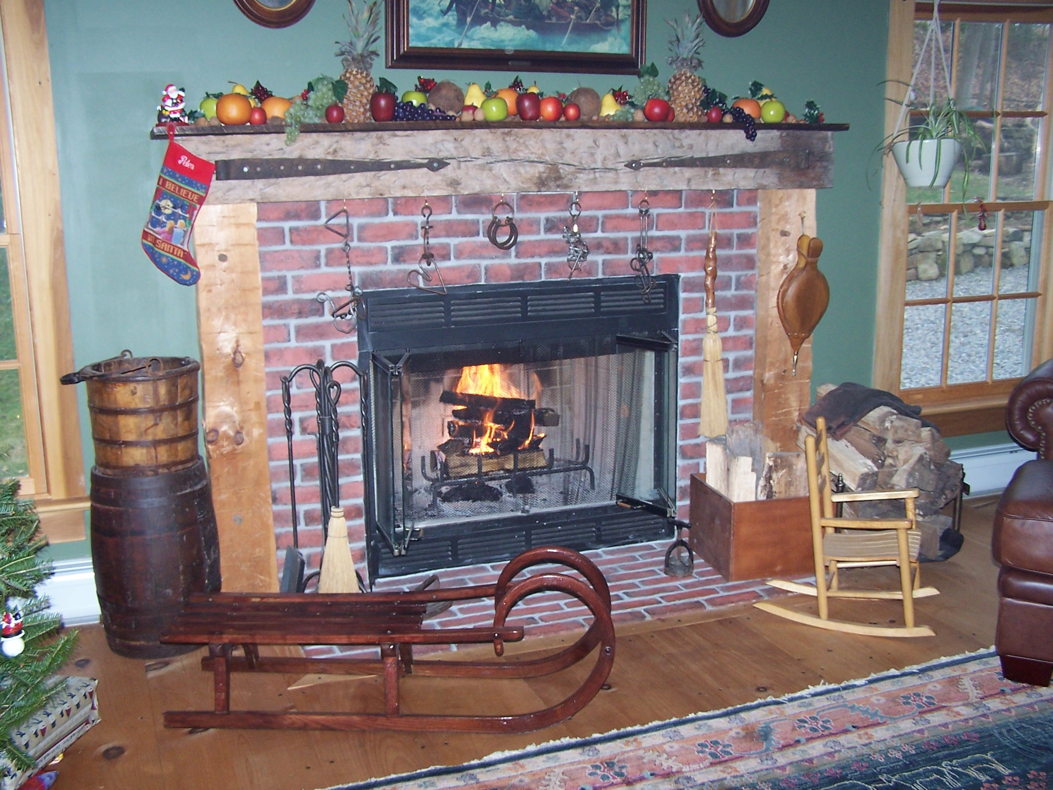

Chester Historical Society’s

News & Views

P.O. Box 376, Chester, NJ 07930
(908) 879-2761
This newsletter is published 4 times a year by the Chester Historical Society.
Editor: Cindy Murphy – (908) 879-1754
Distribution: Brian and Cindy Murphy

News & Views Preservation – Information – Education Page 4
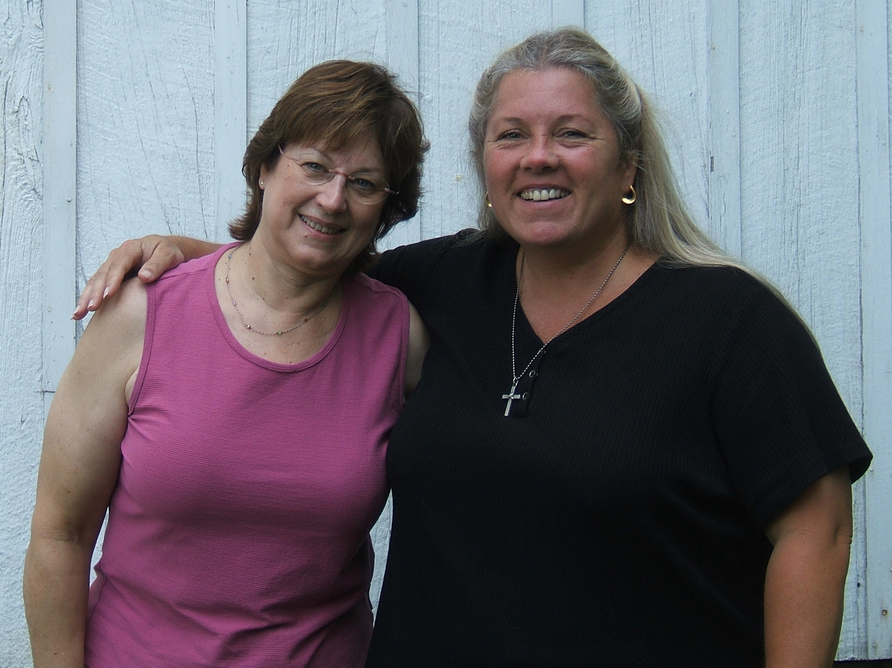
Incoming CHS president Carol Zaikowski (left) and outgoing CHS president Joan Case pose for the paparazzi at the CHS picnic.

… Picnic, Continued from page 1

Lori Sliker, our Archives chairperson, showed the audience two large antique portraits of Mr. and Mrs. Swayze, who were early settlers of Chester. Descendants of the Swayzes recently donated the portraits to the CHS. Lori also showed an antique light fixture that is part of our collection. It once hung in the Publick House, and it will soon be returning there where it will be part of the decor.
Then it was time to eat! As usual, the highlight of the meal was the sumptuous platters of ham, brisket, and turkey, cooked to perfection and artistically presented by Chris Caro, Norma Pereira, and Lois Taylor. We thank them for all the time and effort it takes to contribute this traditional and delicious feature of the CHS picnic fare.
A great array of salads and side dishes graced the two-picnic-table length of the buffet. The wonderful homemade dishes made for tasty accompaniments to the entrees. Thanks to all for providing us with such a wonderful meal!
A little break was taken between courses to listen to the spirited plucking, strumming, and fiddling of Monday Night Jam while the dessert table was
being set up. More homemade and exotic bakery delicacies were offered to finish off a yummy repast.
Marie Ruzicka wrapped up the fun with her traditional lottery game. Marie distributed numbered tickets and called out the randomly selected winning numbers. Lucky number holders were able to select from a table of thoughtful prizes Marie provided, or to take home one of the lovely floral table arrangements that Eileen and Ray Griffith had so graciously contributed to the affair.
With bluegrass music, delicious food, a productive business meeting, an interesting artifact show and tell, a game with prizes, help from all those who lent a hand, and some quietly whirring fans, the humid sultry day was thoroughly enjoyed by all who attended. If you missed this year's picnic, you were missed and we hope to see you next year!

Joan Case is continuing her work on our website. Thanks to her dedication, it has grown into an informative site to learn about our town, its buildings, and its people. Joan would love to hear from you regarding the website.
You can also have your own memories of life in Chester added to the site. Simply email your suggestions, your comments, or your memories to HistoricChester@aol.com .

News & Views Preservation – Information – Education Page 5

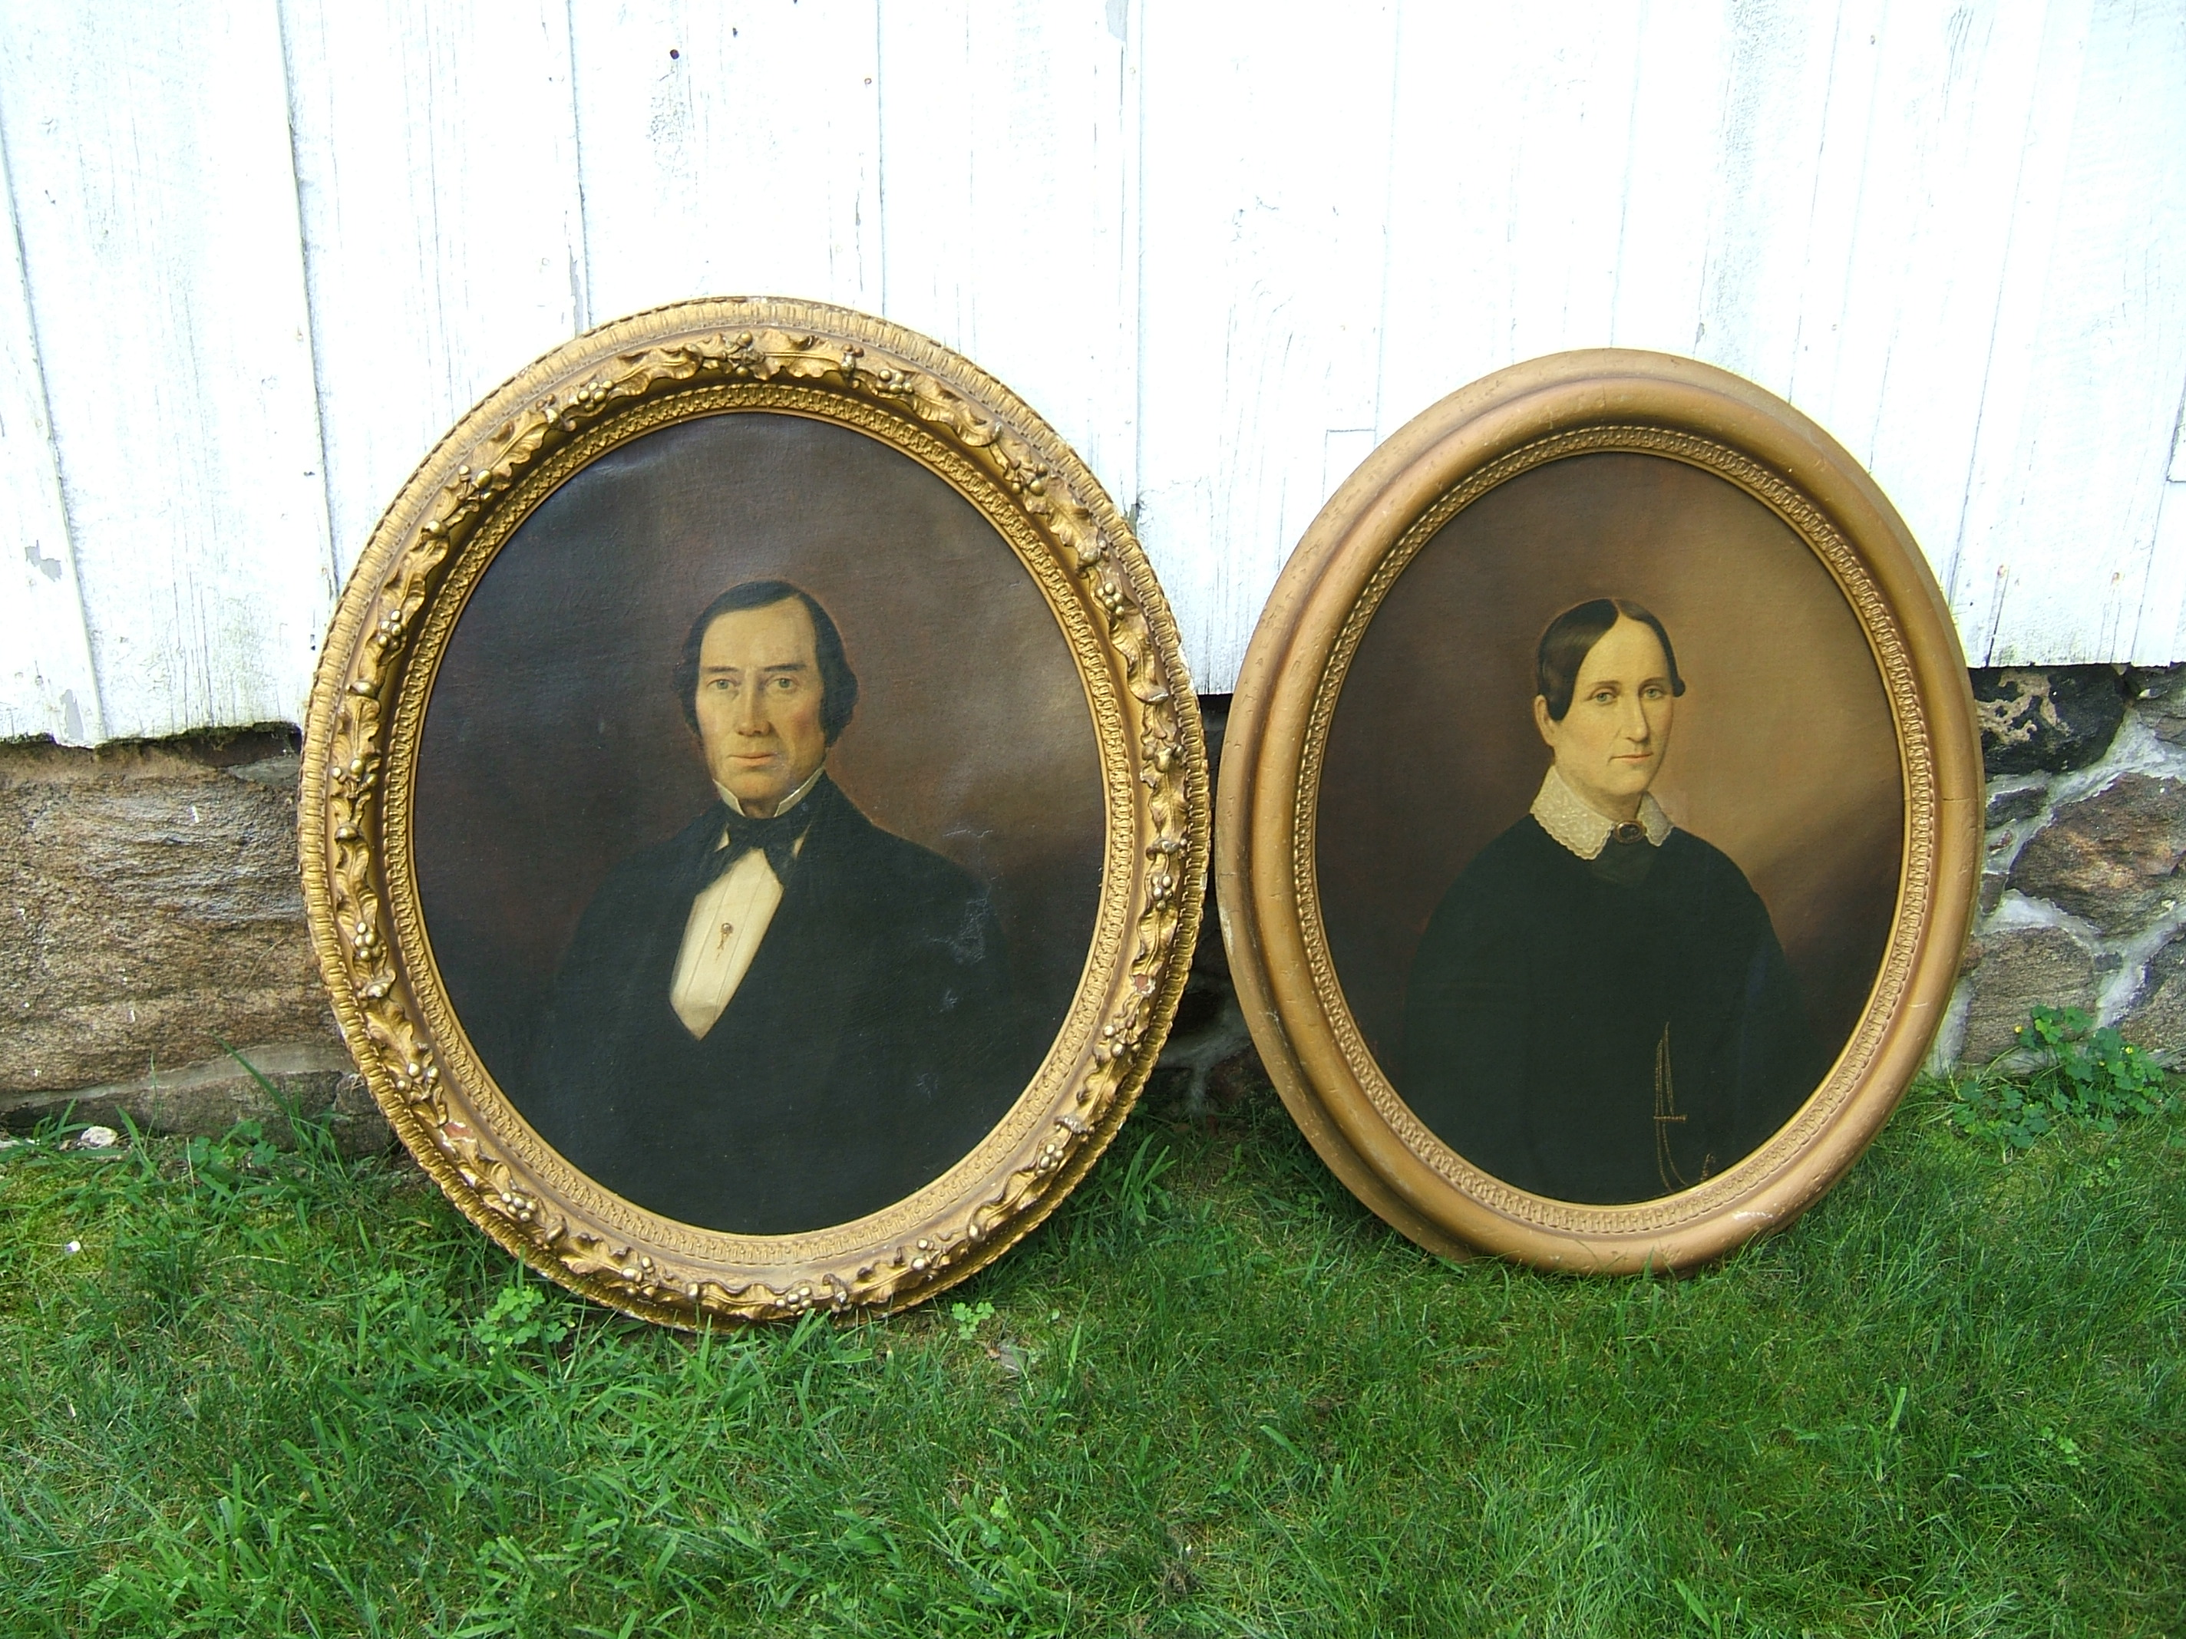
The portraits of Samuel Willets Swayze, II and his wife, Mary Woolley Backer, were on display at our annual summer picnic.

The Swayze Portraits
Recently the Chester Historical Society received a very generous donation of two beautiful portraits. We received the following letter from the donor, Samuel Keavy:

Enclosed are pictures of the portraits of Samuel Willets Swayze, II and Mary Woolley Backer (his wife). They were the parents of my mother’s father, Mr. Theodore Swayze. My mother, Mary Lisabel Swayze, was born in Chester on November 26, 1905.
Theodore Swayze married Marie Killen, a Nantucket native who, after graduating from Framingham State Teachers College, took a position as a teacher in a Chester elementary school. Evidently that’s how they met. They had two other children, Samuel Willets Swayze, III, and a boy who died at an early age.
The marriage of Theodore and Marie was short lived (five or six years). Marie took the children and moved back to Nantucket. She taught school there and lived a long and productive life. Her husband stayed on in Chester and eventually became superintendent of the gas works in New York City. He died of a heart attack while investigating an underground explosion in that city.
Theodore Swayze had a sister whom we can only identify as Belle. We think this was short for Lisabel. It appears that my mother was named for this woman who would have been her aunt. Belle eventually married a man named Victor Berger who inherited the Swayze farm after her death.
We will search family records and will notify you of any additional information we find.

Very truly yours,

Samuel W. Keavy

Barnstable, MA

DUNKER MANIA

By Len Taylor

Back when the Chester firemen’s carnival was hand made and mechanized rides were toy wagons, they always had a “dunker.” In case you are unfamiliar with a dunker, it involves a collapsible seat, a bullseye, a deep but small above ground pool and a select group of local important people to sit in the seat. For a price you get some baseballs to throw at the generous bullseye and, if you hit it, the seat unlatches and dunks the sitter into the pool. The thrill of the dunk is the prize.
At the church fair, they always borrowed the firemen’s dunker until some fireman lawyer mentioned “liability.” That’s how the church decided they had to have a dunker of their own. Simple. Hahahahahaha! I volunteered.
Well, you need a design. Arnold Smith. You need a welder. Gary Sherman. You need angle iron and cold rolled steel rods. Paul Stroud. You need an arc welding machine. Paul again. You need a pool. Chester Hardware. You need a pool liner. Any old plastic sheet will do. And you need some labor.
Gary and I decided to build this thing way out on Pleasant Hill Road. The angle iron and cold rolled steel pieces were not all that heavy separately, but welded together, this work of art got heavier and heavier. Finished, it took two strong men to lift it, but most importantly, it worked…and better than the firemen’s ever did. I think we owed our striking success to the hair trigger release we salvaged from an old ten-gauge shotgun with blown barrels. Probably came from Dink’s gun and powder shop on Church Street. Dink sold and fixed guns in his house. Black powder and parts were stored in his back yard barn.
We bolted the sheet metal into a rough circle and loaded the 150 pound dunker, the sheet metal pool frame and the liner into a station wagon and headed down Pleasant Hill Road to the church.
That road still had the whoop-de-doos in it for
resting horses pulling wagons, and we dumped the dunker into Pleasant Hill Road twice before we got to the church.

It was dark by the time we got there so we hoisted the dunker frame onto its platform over the pool and headed home. We would fill the pool just before the fair, which was a week away. Wow! Ahead of schedule and way under budget.
Between the delivery and the fair, one of the dunker workers invited us for dinner. The wife, barely out of high school and just a few months beyond her wedding dress, served an uncooked shrimp cocktail (sushi before we’d ever heard the word), an entrée I do not remember and a dessert pie straight from the freezer. The husband was mortified. We were hungry. The wife thought maybe she needed some lessons in the nuances of prepared food.
The Friday night that Gary and I went back to wrap red, white and blue crepe paper on this ugly iron contraption and to fill the pool, our arrival greeting was the unmistakable explosion of a cherry bomb. We laughed, both wishing we had a few cherry bombs for our own mischief. The pool fill rate was zero because the cherry bomb had shredded the pool liner. Some plastic covering from the book booth saved us from disaster. Time for the fill - five hours. Our wives thought we had gone to the Hillside Lounge or the Old Mill.
The effort was well worth it. The dunker proved to be really popular. It cost only a quarter to dunk a mayor, the police chief, the fire chief, the minister or maybe even your cranky neighbor into a pool of filthy tepid water. We had fun with the dunker for years until the trigger release finally wore out. There were no more shotgun hair triggers available because Dink’s barn had blown up. The dunker went the way of all fads and was replaced by the excitement of savagely sledge hammering a derelict automobile into a lump.



News & Views Preservation – Information – Education Page 6

Dane participated in the research of local Civil War veterans by deciphering tombstones and recording names and burial sites in local cemeteries. Dane was also a contributor to the design of the veterans memorial.
Dane's interests are varied and include participation in the high school jazz band and wind ensemble as a trombone player, serving as a varsity football game cameraman, playing main roles in WMMHS drama productions, and participating as a member and president of both the American Politics Club and the Historical Society at school. He is also a 3-time recipient of the "You Are a Star" award from WMMHS. Dane plans to attend Mount St. Mary's in Maryland in the fall.
The Croot Award is named for a well- known and respected Chester family that established its roots here after coming from England in the early 1800s. The Croot Award offers a $1000 scholarship to each recipient, and is presented on an annual basis by the Chester Historical Society.

CHS Presents
Croot Award Scholarships
By Alison Dahl, Program Chairperson

The Chester Historical Society announced its 2006 Croot Award recipients, naming Lindsey Asdal and Dane Devereux as this year's scholarship awardees. The Croot Award honors local graduating high school seniors who show an
appreciation of local history as demonstrated through community service.
Lindsay Asdal, daughter of William and Marcia Asdal, is one of the founding members of the Grist Mill Weavers, a group of youths who demonstrate and teach the arts of weaving and spinning with leader Carmen Smith. The Grist Mill Weavers volunteer at such events as Colonial Crafts Day at
the Bragg School in Chester and the Cooper Grist Mill's "Sheep to Shawl" event. They have also contributed to an exhibit at the Madison Museum of Early Trades.
Lindsey also volunteered for several years at the Cooper Grist Mill as an interpretive assistant, helping with tours on site.
The Salutatorian of her graduating class at West Morris Mendham High School, Lindsey is also a private pilot with an instrument rating, a 2005 New Jersey Governor's School Scholar, and a Commended National Merit Scholar. Currently, Lindsey attends the United States Naval Academy in Annapolis, Maryland, and plans to major in aerospace engineering.
Dane Devereux, son of Christopher and Lisa Devereux, has been a member of the West Morris Mendham Historical Society throughout high school, and served as the organization's president this year.
The West Morris Mendham Historical Society set a goal to establish a Veterans Memorial on the high school campus, which was dedicated on Memorial Day 2006. To raise funds for the $30,000 memorial, the West Morris Mendham Historical Society wrote and published a book entitled, "If I Fall." The book is a Civil War era history of Mendham and Chester. The memorial on the high school campus recognizes more than fifty-five veterans from Chester and Mendham who fought in the American Revolution, the Civil War, the War of 1812, World War I, World War II, the Korean Conflict, and the Viet Nam War.

News & Views Preservation – Information – Education Page 7

We Need Your Help!



The Chester Historical Society gets occasional inquiries from people doing family and other historical research. Volunteers are needed to help do light research on former residents of Chester and the surrounding area. Spread the word… maybe you know someone who would enjoy helping others discover their roots! If you are interested in helping please contact the Society either by email at HistoricChester@aol.com or by telephone at 908-879-2761 and leave a message on our answering machine.
Check out the “Geneaology Queries” page on our website at www.HistoricChesterNJ.com to view some of the interesting inquiries we have received.

Chester

Upcoming Programs
Mark Your Calendars!

All programs take place at the Chester library at 7:00 PM unless otherwise noted.

Thursday, September 14: "A Visit with Louisa May Alcott" Jeanne Austin recaptures the spirit and style of this intellectual and philosophical social reformist and author of Little Women and other classic books.
Thursday, October 12th: Get in the spirit of Halloween as raconteur Matt Little relates the folklore, legends, and little known facts about local sites, events, and people from the area's past.
Thursday, November 9th: Author Gordon T. Ward details his 1800-mile journey by canoe and bicycle to revisit places explored by Lewis and Clark as they searched for the Northwest Passage.
Sunday, December 3: Time and place to be announced at a later date - Annual Chester Historical Society Holiday Party - details to follow!
Historical
Society
(Terms Beginning Oct. 1, 2005)
Elected to Board of Trustees

Joan Case President
Carmen Smith Vice-President
Ed Ng Treasurer
Lois Taylor Corresponding Secretary
Elaine Hanington Recording Secretary
Helen Jones Member-at-Large
Brian Murphy Member-at-Large

Appointed To Board of Trustees

Lori Sliker Archives Preservation
Matt Koppinger Architectural Preservation
George Gibb Financial/Legal
Merry Morton Historic Sites
Carol Zaikowski Membership
Jackie Wachsmuth Oral History
Alison Dahl Programs
Marie Ruzicka Publications
Ed Hanington Borough Historian
Len Taylor Township Historian

Chester Historical Society
P.O. Box 376
Chester, NJ 07930
Summer 2006

