Chester Historical Society’s

Chester Historical Society, P.O. Box 376, Chester, NJ 07930 Summer 2007
Web Site: www.HistoricChesterNJ.com ― Email: HistoricChester@gmail.com― Phone: 908-879-2761

The Anthracite Hotel
By Joan Case

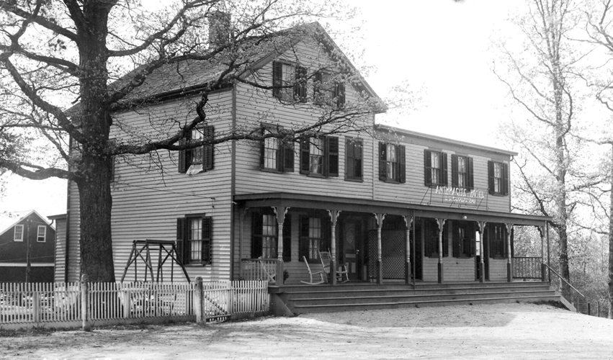
The Anthracite Hotel, once a popular tavern, is now known as Bernie’s Hillside.

At the time of Chester’s Centennial (1899), there were three hotels: The Chester House, The Union House at the Crossroads and The Depot House, near the Lackawanna Railroad Station. Charles Cumback was the proprietor at that time.
Andrew J. Rockafeller managed several hotels in Chester, including the Depot House in which he worked for several years before 1906. Actually, he bartended for the owner, Charles Cumback, and after Charles died, he continued on for Mrs. Cumback. His brother was John P. Rockafeller who owned the Milltown store, now the Old Mill Tavern.
In 1906, Lorenzo T. Current, a butter man working at the Huntsville Creamery in Sussex County, was in route to Whitehouse Station to visit his stepfather’s brother who ran the creamery there. He left from Newton by horse and spring wagon. He traveled down through Andover, Cranberry Lake, Stanhope, Netcong, Flanders, and Bartley before arriving in Chester. Along that narrow dirt road, he stopped in the tavern near the railroad station for some rest and refreshment. Mr. Current found out that the establishment was for sale, took a notion to buy it and he did!
Lorenzo, his wife Arminda and their three daughters, Hazel, Blanch and Bertha, moved to their new home and put on a large addition. They called it the Anthracite Hotel after the type of coal that the

…See Anthracite Hotel, page 2

….Continued on page 2
News & Views Preservation – Information – Education Page 1
News & Views Preservation – Information – Education Page 2
… Anthracite Hotel, continued from page 1

trains carried through the area. At that time, it was a three-bedroom frame house without a porch. The ballroom/bar was downstairs. Along with the addition, Lorenzo built barns in the back to use as a livery stable and an icehouse.
In that day, the Anthracite was a “travelers place” or a “transient place,” as it seemed to attract people passing by on the road or coming in on the train. After the addition was built, there was room for travelers to stay overnight. Some of the guests were workers from the railroad, such as conductors, brakemen and engineers. At one point, they had a total of 33 boarders. This was probably during a storm and the majority of the guests were likely linemen
from the railroad. Lorenzo fed the men well with a hot dinner and soup, and Arminda would pack their lunches for the next day. In the summertime, many apple pickers would come out from New York on the trains. Some would have purchased the whole orchard and just come out to pick their apples.
Lorenzo and Arminda were known for their wonderful meals at the hotel and when the “lay over crews” came in from the railroad, they enjoyed not only clean rooms, but also the freshly prepared food. Hazel Apgar, daughter of Lorenzo Current, recalled the extra services they provided. For instance, one time during an ice storm, 39 passengers, the crew and linemen were stranded on the train in Port Murray. Lorenzo hitched up his buggy and drove there with hot soup, coffee and sandwiches.
There was a pond behind the hotel, and Lorenzo would take his horse out on the pond and pull in cakes of ice to store in the icehouse. The cakes of ice usually were about 1 foot by 1 foot blocks and the thicker the ice, the better! When stacking it, they put a layer of blocks in one direction and the next in another, stacking it up to the top of the building. They then filled the icehouse with sawdust to give it some insulation. When they needed ice for the iceboxes inside the house and hotel, they had a ready supply.

Hazel remembers a “Krueger’s Beer” keg sitting alongside the barn, out behind the hotel. At the base of this barrel were many little piglets and the barrel, filled with milk, was acting as a surrogate mother for the piglets. There were feeding tubes all around it and the Current family raised the whole litter of pigs this way. Lorenzo even sent the Kruger Beer Company a photo of it, thinking it would make a great advertisement, but he never heard back from them. This same keg appears in a photo of the family in front of the hotel.
The DL&W Train Station sat at an angle just across the street from the hotel. The trains not only carried passengers down to Dover, but also carried the local produce and milk from the farmers. Down the line from the hotel was a creamery owned by Mr. Holthufan. Farmers would bring their cans of milk there to be shipped out of town. If the train had already left, they would just set the cans down in the back where the cold spring water was, and they would be picked up the next day. The creamery sat alongside the tracks for easy loading and unloading and was close to Pleasant Hill Road. It still stands today as a private residence. After growing up at the hotel and seeing how things operated then, Hazel often wondered why we got so fussy about milk and why it now has to be pasteurized. She remembered that the milk back then was just fine and the farmers never had to sterilize the cans they used.
During Prohibition, the hotel was almost ruined. Of course, like many other places in Chester at that time, you could still obtain your “beverage of choice” because many people had their own stills in operation. Hazel remembered that when the ABC Federal Cops came to check on the operations, Lorenzo dumped the mash contents of his still out behind the barn and all the chickens got drunk. Rick Apgar (Hazel’s grandson) remembers Lorenzo’s old still and that it was kept in the cellar under the steps.
Lorenzo passed away in 1922 at the age of 46. Arminda kept the hotel going and later

…See page 5, Anthracite Hotel

News & Views Preservation – Information – Education Page 3

President’s Message
By Carol Zaikowski

Barbara and George Gibb recently handed over to me their personal copy of the Chester Township and Chester Borough Historic Sites Survey done in the mid 1980’s. I have gone through the survey available in the Library, but I was always looking for something specific and never had the time to read it through. Many of these surveys read like a good book to me. Being stuck at home with plumbing and heating crews coming and going for days and days, it was a good opportunity to crack open the book and take it all in, cover to cover. I was particularly taken with the “Acknowledgments” and “Personnel” pages about midway through the book, between the Township and Borough sections.
For those members who like myself are fairly new to the Society and don’t know all we wish we knew about Chester or the CHS, it is humbling to realize that the survey was done (with help from the local as well as professional communities) by a handful of CHS members: Project Coordinator: Carmen H. Smith; Research Assistants: Kathleen Appis, Merry Morton, Anita Rhodes; Typist: Elaine Hanington; Photographers: Kathleen Appis, Karl Brecheisen, Kenneth Caro, Merry Morton, Leonard Taylor, Beth Zeigler, Joan Case; Aides: Marleen Appis, Dorothy Morton, Christine Stadtmueller, Dory Lee Rachel, Maggie Smyth, Sonya P. Reutelhuber. The names are all familiar to me, many people are still active members – some have moved away and some have left us, certainly for a “loftier” home in the most historic place of all.
It is important to recognize that nothing is impossible when you bring together people with a common interest, a common cause, and a common goal. This was a huge undertaking and an incredible commitment of time by people who love their towns and are committed to preserving the tangible and visual record as well as the written record.
I still see this commitment to history in many CHS members. But we would like to have more

help from the greater membership.
A little time each, spent by many volunteers will accomplish a lot. Yes, the archives will always need a lot of attention – but so, too, do our Historic Sites, Publication, and Publicity committees. And we need someone to start a Genealogy Committee. Please consider volunteering a little of your time and continue the spirit of commitment that has defined the Chester Historical Society.

Archives Report
By Carol Zaikowski

We have had some new additions to our archives over the last few months.

Thank you to Beryl Apgar and Georgia Apgar Case for contributing the framed, aerial photograph of George Apgar’s Garage.

Thanks also to Len Taylor for a publication entitled, The Chester Railroad Company, Charter, Laws and Lease, 1867-1886 and for his donation of a Tippet bottle, ca 1880, which was dredged from Lake Hopatcong in 2006.

Thank you to Michael Roth for the 1926 Dedication Exercise Program, Chester Public School (Williamson School).

And finally, thank you to Carmen Smith’s daughter Claire, for donating Carmen’s famous picnic hat and her CHS files and memorabilia, including photos, research, and a whole bunch of other interesting items.

We appreciate the thoughtfulness of our members in contributing materials related to Chester’s history. Some items have been left in the library with no explanation about their origin, significance or contributor. In order to assure that the items make it safely into our collection, please call me at 876-9599 if you have material that you wish to donate and think would be appropriate for our archives.

…Please see Archives, page 5

Upcoming Program Reminder
By Alison Dahl, Program Chairman

Thursday, Sept. 13 - "The History of Greystone"

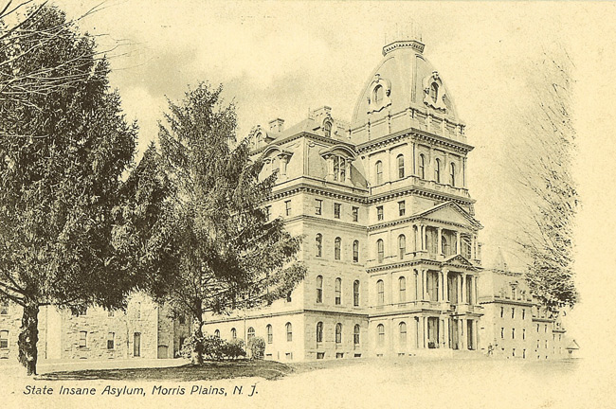

Shake off the fears and misconceptions you may have about Greystone Psychiatric Hospital, and learn of its history from 1875-1950. Peg Schultz, History Program Coordinator for the Morris County Heritage Commission, will present an in depth discussion of this intriguing facility.
Ms. Schultz is well versed in Greystone's history, having completed her Master's thesis on this subject, which is also the subject of her PhD dissertation, in progress through SUNY Binghamton. Ms. Schultz is an adjunct instructor in the History Dept. of William Paterson University, where she earned her M.A. in History.

Thursday, Oct. 11th, - "Ghosts at our Doorsteps"

We welcome back author and educator Gordon T. Ward as a Chester Historical Society presenter, just in time for Halloween, to entertain us with ghostlore and classic tales from near and far. The program "places an emphasis on ghostlore as entertainment and celebrates the importance of documenting local stories and sharing them in the oral tradition" according the Mr. Ward's description.
Mr. Ward's slide show and lecture will include ghostlore related to many historic sites

in the Somerset, Morris, and Hunterdon County areas of New Jersey. Learn what ghostlore can teach us about our past at this fascinating program.

Thursday, Nov. 8th - "Pioneer Soap Making"

Get ready to laugh and learn with another returning presenter, Jane Chrysostom, as she presents part of her "Homesteading 101" series of lectures. Ms. Chrysostom's specializes in the study of early American women's pioneering skills, and describes her soap making program as learning how to make a bucket of fat into a bar of soap. She's delightfully humorous.
Ms. Chrysostom runs a B&B in Canada from May through October, then returns to her lecture circuit for the winter months. Soap making was often done in preparation for the approaching winter, so this is perfect timing, and you'll bring a bar home with you!

Reminder: Meetings are held in the Larison room at the Chester Library. They begin at 7:00 PM. Refreshments are provided after the meeting.
News & Views Preservation – Information – Education Page 4

Croot Scholarship Award Winner Named
By Lois Taylor

This year’s recipient of the Croot Award was Annie Rose Asdal. Annie Rose is one of the original Gristmill Weavers. Her interest in local history was told beautifully in her award- winning essay.
Annie Rose, who may be seen flying over Chester, will be attending Duke University this fall. This accomplished young woman is a pilot, a musician, an athlete, a scholar and a tireless volunteer. She is the daughter of William and Marcia Asdal. The Chester Historical Society gives the Croot Award because of young people like Annie Rose. The award is presented each year to a local graduating senior who demonstrates an appreciation of local history through community service.

Cooking With The Coopers Once More
By Cindy Murphy

Some time ago I included an article in the newsletter related to the Cooper Family Cookbook. The cookbook is part of a collection purchased by the CHS. I thought it might be fun to include a few more recipes. Keep in mind that they read more like lists of ingredients and contain few details or instructions. In fact, at times ingredients are listed, but aren’t mentioned in the instructions. Consider the following:

Ginger Snaps 2

1 pt of molasses
2 tea cups butter
1 teaspoon of soda
½ tea cup sugar
2 teaspoons of ginger
Add flour enough to roll out easy.

Stir butter and sugar together. Boil the Molasses. Stir in butter and sugar while boiling. Add a few hands full of flour and the soda to be rolled out very thin. Bake quickly.

If you are wondering, there is an earlier entry simply titled Ginger Snaps, which I suppose is short for Ginger Snaps 1. There wasn’t much to go on with that one.

…See Coopers, page 9

www.historicchesternj.com

Have checked out the website lately? It has grown quite a bit thanks to the hard work and dedication of Joan Case. Remember, you can also have your own memories of life in Chester added to the site. We also welcome your suggestions and comments Simply email us at HistoricChester@gmail.com.

2007 marks the fortieth anniversary for the creation of the NJ Historic Sites Council and NJ Historic Trust. In 1967, the historic preservation movement was in its infancy and the challenge of saving history was largely in the hands of dedicated and passionate volunteers. Today, NJ boasts one of the earliest and most successful bricks and mortar programs in the country; laws, programs and professional standards have become intertwined in our land use planning. Hosted by Drew University, this year’s conference seeks to remember our accomplished past while charting a comprehensive course for New Jersey’s future.

News & Views Preservation – Information – Education Page 5
…Anthracite Hotel, Continued from page 2

married a trainman who was boarding at the hotel. She passed away soon after giving birth at age 48. The hotel was eventually sold to William Kohler, who sold it to Edward Hann. After the trains stopped running, Hann continued to operate the tavern with some “rousing cockfights” as entertainment. After his death, the tavern was left to his niece, Luella O’Neil, who sold it to Bernie Wallace. Bernie Wallace, Jr. now operates it as “Bernie’s Hillside,” and they still serve food and have music on the weekends. Stop in some time for food and drink and dream of days gone by.

…Archives, Continued from page 3

I, or another member of our committee would be happy to meet with you at the library to discuss your donation.
Work on the archives will continue as volunteers sort through the collection. More help is needed in order to complete this phase of processing. We also could use help in the History Room recording those items already on the shelves and in composing the text for signs that will describe items and maps on display.
If you are interested in volunteering for these or other projects, please call me at 876-9599. Thank you.

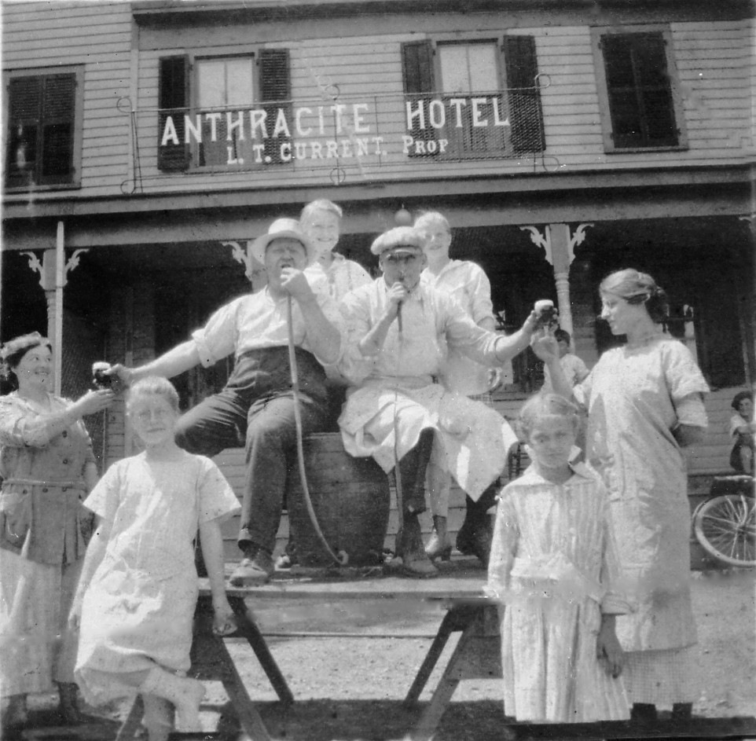
This photo shows Lorenzo Cutter and his family in front of the Anthracite Hotel. The keg is the same one that Lorenzo once used to feed a litter of pigs!

featured thoughtful gifts that Marie gathered in her travels. Barbara Gibb drew the lucky number for this year's grand prize -- congratulations, Barbara, and thank you, Marie.
It started to rain, but that was okay. We were full, and happy, and had a good time. The band packed up and the revelers headed home.
Much appreciation goes to all those who came early or stayed late to help set up and clean up, too. Many hands make light work -- it was a pleasure working, and playing, together. Let's do it again next year!

Summer Picnic Brings Awards, Music, Great Food and Fun!
By Alison Dahl

The cool gray weather provided an interesting atmosphere for the more than sixty members and guests who attended this year's Chester Historical Society summer picnic at the Cooper Mill carriage house.
Attendees were welcomed to the festivities by the upbeat bluegrass music of "Monday Night Jam" -- back by popular demand for their second gig with the CHS. Thanks to the band for keeping our toes tapping and spirits cheery -- you really sounded great!
As we gathered, folks chatted and caught up on each other's news prior to our President Carol Zaikowski opening the Annual Business Meeting. Carol began by bringing us up to date on our accomplishments and worsk in progress. She led us through the election of officers, and then introduced Matt Koppinger, who presented the CHS Architectural Merit Award to Rich and Mary Christie (See related story). Meeting adjourned, minutes duly taken by the ever-diligent Elaine Hanington -- it was time to eat!
The food was, in keeping with tradition, beautifully presented, delicious, and plentiful. Our thanks to Chris Caro for her marvelous brisket, Norma Pereira for her glorious ham, and Lois Taylor for her tasty turkey, as well as for the special touches they lend to serving with such lovely style.
Speaking of special touches, Eileen Griffith's delightful fresh flower arrangements graced each dining table again this year, adding as usual a bit of elegance to the picnic ambience. Eileen's flower arrangements become coveted "door prizes" when the picnic winds down.
The main course table was brimming with a grand array of salads and side dishes that members brought. And the desserts! Oh, the desserts! Yum! And all non-fat, low-calorie, sugar free -- amazing. Thanks to all for sharing such delicious culinary confections.
We wrapped up our picnic celebration with Marie Ruzicka's annual prize drawing, which

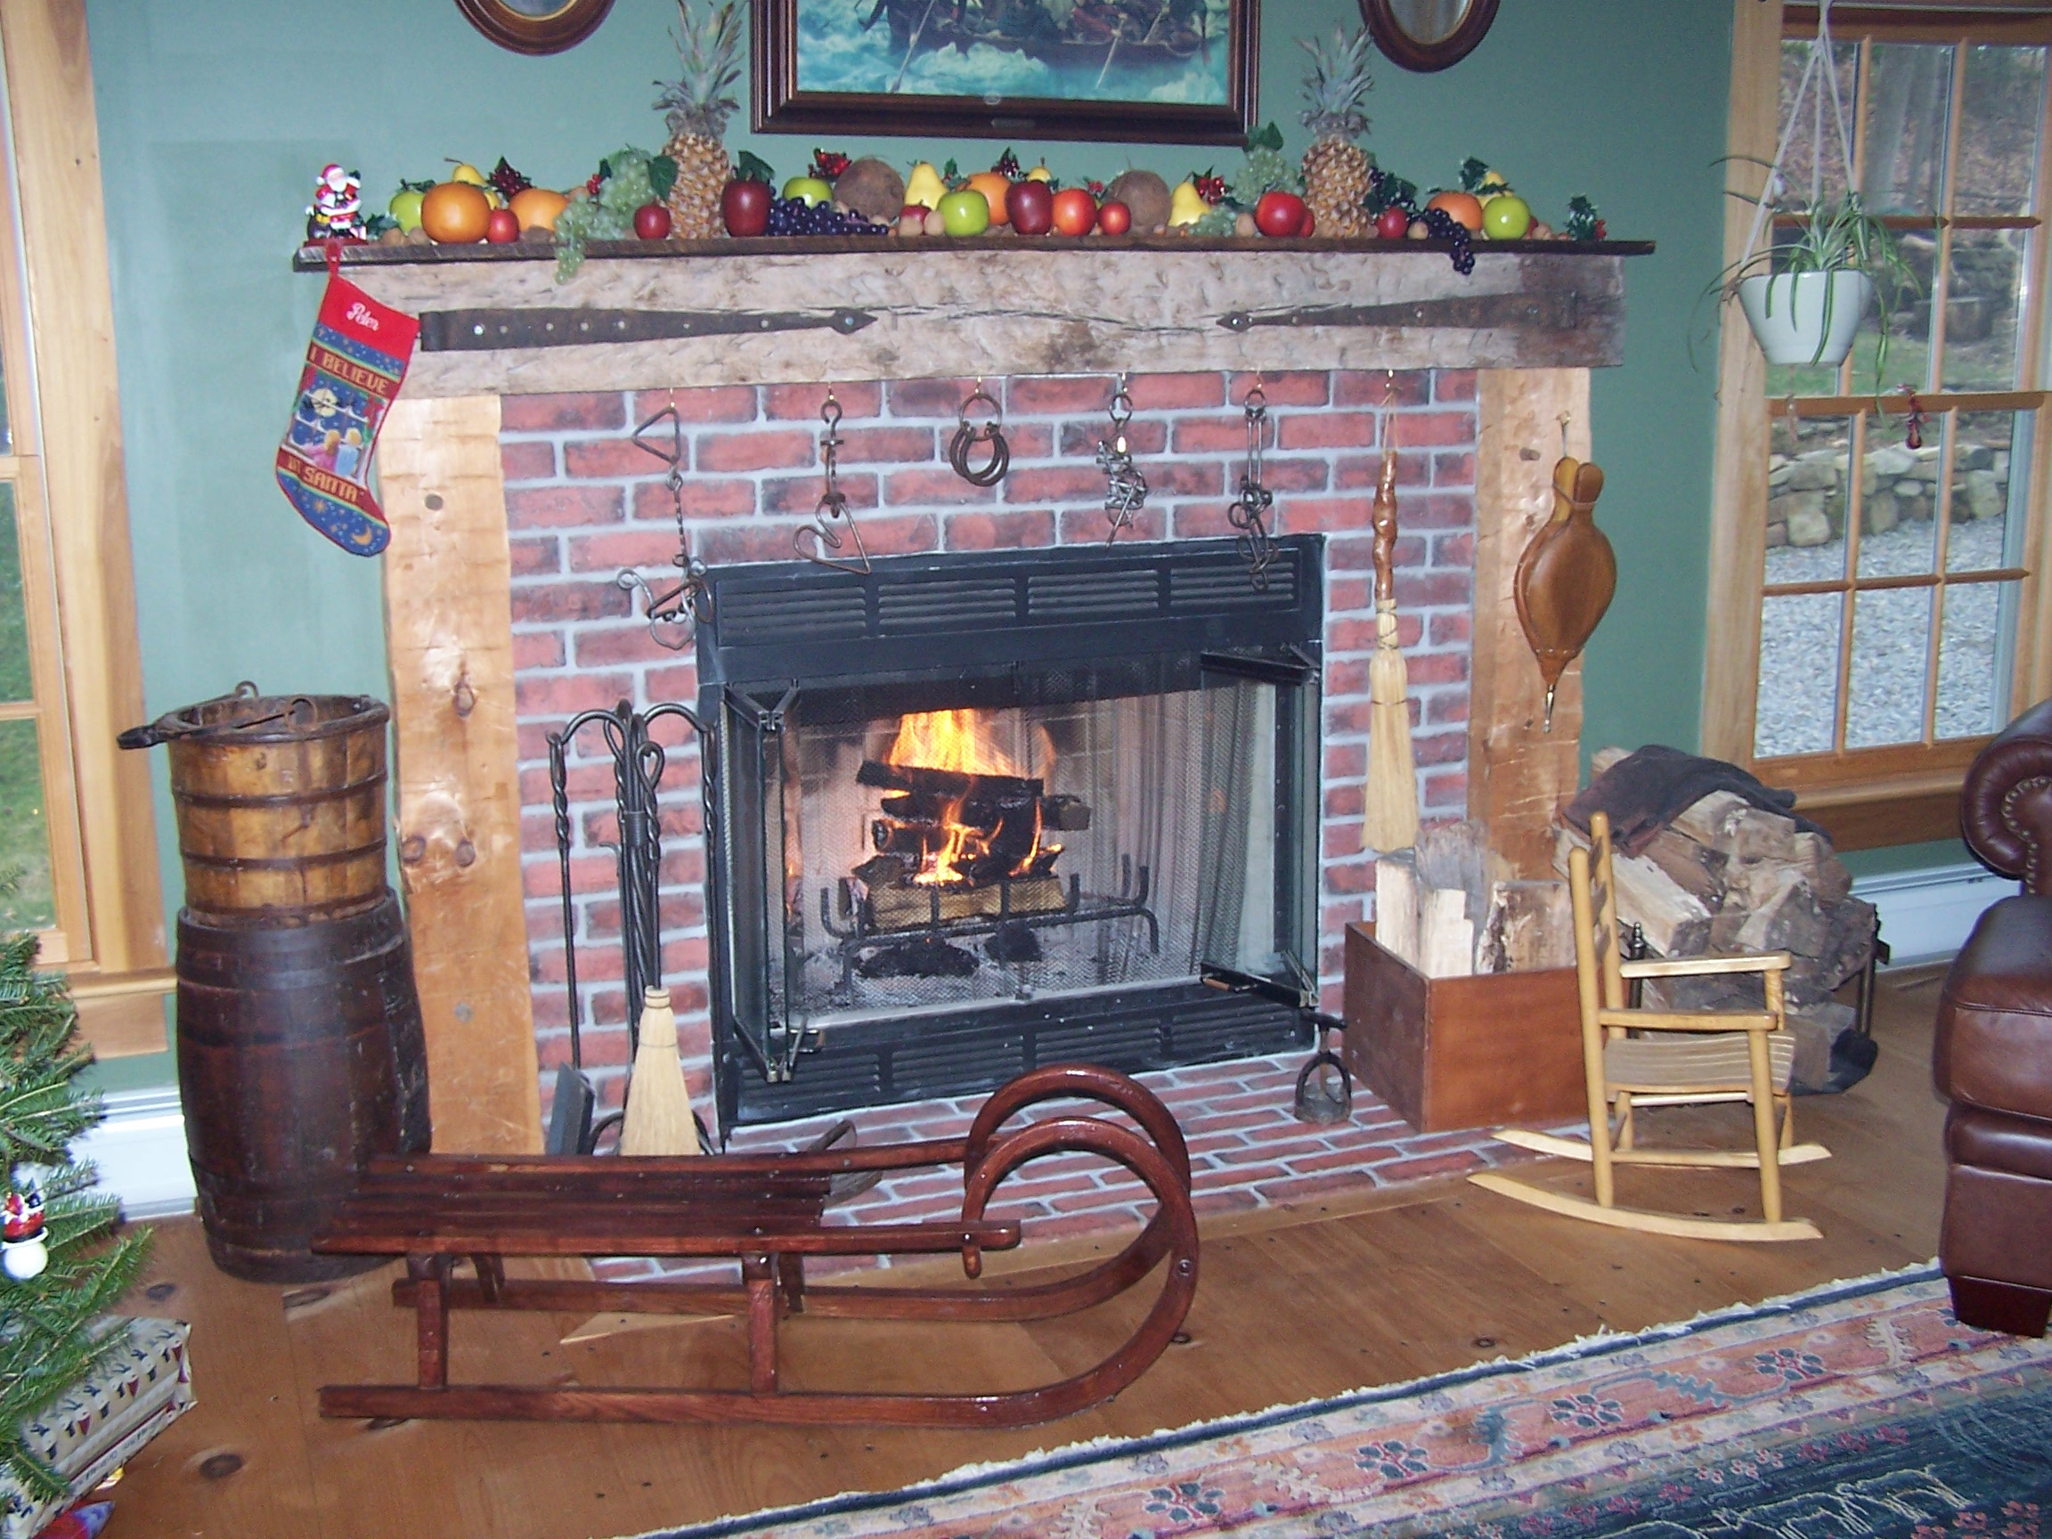

News & Views Preservation – Information – Education Page 6

2007 Architectural Merit Award
By Carol Zaikowski

The Trustees of the Chester Historical Society voted unanimously to award for architecture merit the residence of Rich and Mary Christie for the rehabilitation of their home on Pleasant Hill Road. The presentation was made at the Annual Meeting and Picnic of the CHS on August 19th. The award was designed by Township Historian Len Taylor and presented by Architectural Preservation Committee Chair Matt Koppinger.
The house is known historically as the Leek-Stroud House, probably constructed in the mid-19th century in vernacular style with Italianate detailing. The Christies and their architect have undertaken a wonderful and sensitive renovation, referring to old photos to keep the historic elements of the Leek-Stroud House intact.
Make sure to slow down and take a good look the next time you drive by. We owe a great deal of gratitude to residents who are committed to preserving the historic integrity of our homes.
Thank you and congratulations Rich and Mary!

Presidents Annual Report

October 2006 – September 2007
By Carol Zaikowski

Accomplishments:

The Chester Historical Society continues to maintain a healthy membership and treasury.

Our main focus over the last year has been on the CHS archives, located in both the barn at Highland Park and in the Chester Library. Volunteers have begun the process of sorting through and recording all material that is being stored in both locations. This process is a lengthy one, but necessary to producing a catalog of our collection, to beginning the accessioning and de-accessioning process, to obtaining professional conservator care for those items that need attention, to applying for grant funding, and ultimately to providing an accessible archive to researchers and the public at the Carmen Smith History Room in the Chester Library.

The Chester Historical Society continues to offer interesting and educational programs each month, informative newsletters several times a year, and a CHS website.

CHS also presented a 2007 Croot Award to a Mendham High School Student and an Architecture Merit Award for a rehabilitation project in Chester Township (please see related articles).

Our oral history program is ongoing. We are upgrading our current method of tape recording to digital recording. Currently it is our goal to transfer past records from audio tapes to CD’s and to transcribe audio into written text.

Goals:

The Chester Historical Society -

- has produced several publications over the years and we have many copies in storage. In the past we have made these

News & Views Preservation – Information – Education Page 7

- publications available to the public by offering them through various venues: CHS events and programs; Chester events and programs; Chester businesses. We need volunteers from the CHS to expand our publication committee so that we can continue using only those venues that have proven profitable and to explore other venues and methods of selling publications.

- needs members to volunteer to provide publicity to area newspapers and other media regarding CHS programs, events, and news.

- needs to rebuild our historic sites committee. There have been many changes over the years, and we need to update our records.

CALLING ALL MEMBERS!

The Chester Food Pantry needs our help! The following items are especially needed:

Spaghetti Sauce
Canned Fruit

This time of year there is always a shortage of items available. Any donation will be much appreciated.

Reminder—The Food Pantry’s drop- off areas are in the foyer of the Chester Library and in the exit area of Shop Rite. The box in the Chester Post Office is for the Morristown Pantry.

Many thanks,
Lois Taylor

It was dark by the time we got there so we

News & Views Preservation – Information – Education Page 6

The Danish Soccer Team
By Lois and Len Taylor

As time progresses in the Chesters, this is a relatively recent event. In 1979, during “The Year of the Child,” Morris County sponsored several European adolescent soccer teams to come to the U.S.A. and compete with our local adolescents. Chester hosted a team from Taastrup, Denmark. Coaches and players were spread around the community to stay with various families. This story is about the “Americanization” of one of the coaches, sixteen year old Erik who stayed with the Taylors. His father stayed with a family on State Park Road.
Erik is 6’-5” tall, an impressive height compared to the other teenagers who came with the group. It was July, warm by Danish standards where the weather is usually damp and chilly, and the North Sea and Baltic Sea are cold year ‘round. That particular July was cold, though. Sweaters were the dress of the day.
Erik arrived at our house and immediately filled the whole place. Like his teammates, he was physically fit and really into exercise. Every morning for the first few days he would get up and run. He ran from Furnace Road to Hillside Road and out Route 206, a distance of a few miles, and then came in and had a huge Danish style breakfast of cold cuts, cheese and bread or cereal or both.. The soccer teams would spend the day at locations around Morris County playing whatever teams the communities could send their way, and then in the evening go somewhere for a social event centered around a huge dinner.
By the third or fourth day, Erik was running every morning on the abandoned railroad right-of-way that went from the back of the Taylors to Long Valley and beyond. The run was shorter and he always returned soaking wet from the morning dew on the brush along the way. He would shower and dress, and eat that huge breakfast. In the evening, he would lounge around in strange comfortable clothes.
The soccer teams appeared in the 1979 Fourth of July Parade, with the tallest guy, Erik, marching right up front carrying the Danish Flag. Janet Abeles and Patterson Warlick, the two

mayors at that time, were both in the parade.
The Danes called them “Lord Mayors,” which is what the town leaders are called in Denmark.
By the fifth day, enchanted with sheer number of non-government television stations available, Erik was sleeping a little later and running a little less so he could watch T.V. for a while before leaving for the day. By the end of the first week, breakfast had changed from Danish fare of cheese and cold cuts without fruit to eggs, bacon, toast, potatoes and a quart of orange juice. We just gave him the whole carton. But most American of all, the running had given way to sleeping late and then lounging in bed to watch re-runs of “Loveboat.”
The last few days that Erik spent with us were very “American adolescent.” Wake-up to watch television. Shower. Breakfast of meat, eggs, potatoes, fruit or orange juice and often cereal on the side. Soccer and lunch. Television. Shower. Huge dinner, often at a social gathering. Television. Bedtime and a little more television. No cold cuts, cheese and bread. No running.
Two weeks after the soccer groups arrived Erik and his companions were taken to the buses at Black River Middle School to send them off to JFK Airport and Denmark. It had been a terrific two weeks and the experience had been wonderful for the local teenagers. There was some sadness in the realization that we would probably never see any of these people again.
That was twenty-eight years ago and Erik is now an executive with Skibskredit A/S, which has mortgages totaling $35 billion dollars on 600 vessels worldwide. Is that American or what!
And, oh yes! Erik did not fly away never to be seen again. He has been back to visit almost every year since 1979 and sometimes twice a year. He has attended our family reunions, vacationed with us and been to our weddings and significant birthdays. Erik is an “American in Denmark” thanks largely to just two weeks here in 1979.

News & Views Preservation – Information – Education Page 8
News & Views Preservation – Information – Education Page 9
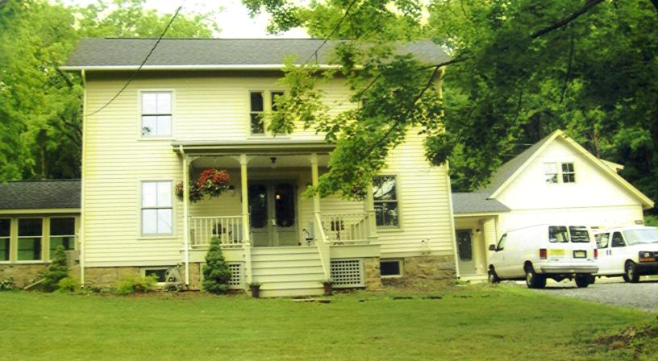

Rich and Mary Christie were awarded the Architectural Merit Award at the annual CHS picnic in August. It is believed that the home, known as the Leek-Stroud House, was built in the mid-19th century.

Remembering Carmen Smith
By Ed and Elaine Hannington

We met Carmen early on, when we first moved to Chester 31 years ago. When she learned that we had purchased an 1873 home on Hillside Road, she encouraged us to research its history. She even accompanied us to the courthouse in Morristown to search in the Hall of Records and Book of Wills. With her help, we were able to trace the previous owners back to the original owner, Deacon Cramer. Her lively interest inspired us, and we treasure knowing who came before us and how long each family lived in the house. Thirty-three years is the record for ownership, and we are fast approaching that mark.
Carmen was not only interested in the history of our property. Her frequent presence at Planning Board meetings ensured that all of Chester’s history would be preserved.
We are blessed to have known Carmen.

In Memoriam

Jean Hansen passed on the sad news that CHS member Helen Budd Vanderbilt passed away in Wisconsin on August 6, 2007. History was important to Helen and she was particularly interested in Chester history. She was a great supporter of the Chester Historical Society. She will be missed.

Chester Historical Society’s

News & Views

P.O. Box 376, Chester, NJ 07930
(908) 879-2761
HistoricChester@gmail.com
This newsletter is published 4 times a year by the Chester Historical Society.
Editor: Cindy Murphy – (908) 879-1754
Distribution: Brian and Cindy Murphy

…Cooper’s, continued from page 5

A few pages later another ginger cookie recipe appears.

Ginger Cookies

1 cup shortening
2/3 cup sugar
2 cups molasses
2 teaspoons soda
2 teaspoons ginger
1 teaspoon salt

Nelly makes ½ of this quantity.

Now first of all, I am wondering why Nelly only makes half of this quantity. It seems to me that the more cookies you bake, the better. I am also wondering if something is missing. Shouldn’t there be some flour? At least enough so that the dough will, “roll out easy?”
I think I may try and make Ginger Snaps 2. I’ll have to guess at what size teacup to use and where to add the ginger, but I think I can figure that out. Wish me luck! If they’re good, I may have to bring them to a CHS program.

Chester
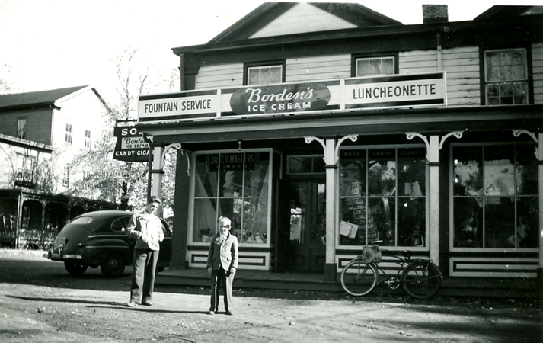
Leck’s Luncheonette was a popular place in the 1940’s and 1950’s. Several businesses occupied the building now known as Pleasant Pools and Patio

Historical
Society

Elected to Board of Trustees

Carol Zaikowski President
Pam Stevens………………………Vice President
Ed Ng Treasurer
Lois Taylor Corresponding Secretary
Elaine Hanington Recording Secretary
Helen Jones Member-at-Large
Dee Dilley Member-at-Large

Appointed To Board of Trustees

Matt Koppinger Architectural Preservation
Carol Zaikowski…………………………………Archives
Amanda Dean Membership
Helen Jones Oral History
Alison Dahl Programs
Marie Ruzicka Publications
Ed Hanington Borough Historian
Len Taylor………………………..Township Historian

Chester Historical Society
P.O. Box 376
Chester, NJ 07930

Summer 2007

