Chester Historical Society’s

Chester Historical Society, P.O. Box 376, Chester, NJ 07930 winter 2008
Web Site: www.HistoricChesterNJ.com ― Email: HistoricChester@gmail.com― Phone: 908-879-2761

The History of the First Congregational Church of Chester
By Joan Case

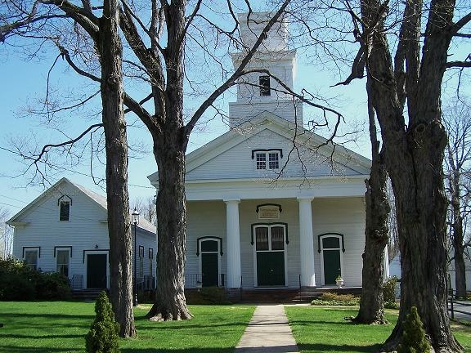
The First Congregational Church of Chester as it stands today. Photo by Joan Case.

The First Congregational Church of Chester, NJ has the honor and distinction of being the oldest Congregational church west of the Hudson River. In 1640 the Reverend John Youngs arrived in New Haven, Connecticut from Hingham, England. A group from the church where he had served as minister accompanied him. They had fled England because of the “tyranny and oppression, and sought asylum for the enjoyment of religious freedom.” From New Haven they moved to Southold, Long Island and around the early 1730s, a group from that Southold church moved into the Chester area (then known as Black River) and set about establishing a church here.

See First Congregational Church, page 4…

….Continued on page 2
News & Views Preservation – Information – Education Page 1
News & Views Preservation – Information – Education Page 2

President’s Message
By Carol Zaikowski

The Chester Historical Society now has a new space to store our archives. Thanks to Chester Township’s generous offer of a room at the Highland Ridge building, the CHS signed a lease last month with the Township for a room in the building that will adequately suit our needs of a climate controlled, clean space in which to store our archives and work on the collections.
The CHS archives have traveled around quite a bit in the last several years, and though Merry Morton had packed them away quite well and documented where everything was, the many years, frequent moving, and forays into the collections to find information, photos, or to put together exhibits has taken its toll. We are in “somewhat organized” disarray but are well on our way to getting things in order.
The new space will make it much easier to properly store and find things. A move from our current location in the barn to Highland Ridge will take place in the very near future. Thanks so much to the CHS Trustees for their support, to CHS member and Trustee Len Taylor for all of his help and guidance, to Dan O’Donnell for his time and suggestions, to our Treasurer Ed Ng for his concerns for our safety, and to Mayor Bill Cogger and the Chester Township Committee for the kind offer and for recognizing how precious Chester’s past is and how important it is to keep it safe and available for future generations.

Have you been to a CHS program lately? Alison Dahl has been putting together great programs for the Historical Society – some of them have drawn people from all over and left us with standing room only. If you want to be informed, entertained, or simply to get together with our great group, come out of hibernation this spring and look into what Alison has in store for you. I don’t think you’ll be disappointed. And if you have an idea for a program that you would like to have presented,

give Alison a call. Hope to see you all soon!

Think Spring!

Antiques Show & Tell Program A Big Hit!
By Alison Dahl

Our "Antiques Show and Tell" program proved to be an enlightening evening on February 14th, presented by the experts from the Chester Antique Mall. Participants brought a wide array of interesting antiques including implements that once belonged to a Civil War soldier, jewelry, and real and reproduced ceramics.
We learned what characteristics to look for to identify antique furniture from Bill Cogger. Bob and Karen Grossman set up a "Whatsit?" table of odd old kitchen tools, and Phil Silvershotz appraised a nice collection of jewelry. Our thanks to each of them for sharing their knowledge, and to participants who brought such interesting items.
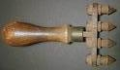
Whatsit?

Rides Offered to CHS Programs

We would like to make it easier to attend our monthly meetings! Members who would like a ride to and from our monthly CHS programs are asked to call Lois Taylor at 908 879-7249. Lois will help make the arrangements for you. If a member is willing to provide transportation, please call Lois to volunteer. Your assistance will be greatly appreciated!

Finding the chester Furnace
By Lois and Len Taylor

Most of us history enthusiasts know the feeling of walking through the forest and finding an old cellar hole, an unusual pile of dirt, an old abandoned building or the remnants of an entire complex. In New Jersey, the chances are that it’s been seen before by a lot of folks, but for you, it’s newly discovered.
Imagine how the Taylors felt when they discovered their property bordered the former site of the Chester Furnace. Our love affair with the Furnace started about the first month we moved to Chester Township, along with years of research. That research proved difficult since the residents who could still remember the standing buildings and who played among the structures as children had “zero” interest in the history of the site. After all, in bygone days, there were only a handful of photographers who would photograph an iron furnace. You took photographs of your family, your home and yourself standing by your car with an exotic roadside attraction in the background.
The Taylor family has been over every inch of the furnace site. Rutgers University has excavated parts of the site and documented the anthropology of the artifacts. Yes, the anthropology, not the archaeology. The Scrapbook of History contains many mentions of the furnace. The Taylor map of the site ruins is in Chester’s Iron Heyday. Coal and a few bricks from the site have been moved to the Taylor’s property to save them from vandals or deterioration. The Taylors have found a large number of artifacts. They are on permanent loan to Morris County for their use at the Cooper Mill or anywhere else they choose. And a book of poetry by W. Taylor, former superintendent of the operation, has been donated to the Chester Historical Society. We didn’t know it when we moved to Chester, but the Taylor ancestor who saved the booklet was a cousin to superintendent Taylor. Somehow it seems appropriate that a latter

day Taylor lives so close to the furnace.
The site, which is on property owned by New Jersey, is gradually melting back into the landscape. Hunters, paintball groups, hikers, tours, horses and bikers have taken their toll. The area is going the way of most abandoned sites and will someday show no evidence at all of what was there.
In the meantime, get out there and see it. Take the spring tour with the Taylors. Grab this important piece of Chester area history and caress it.

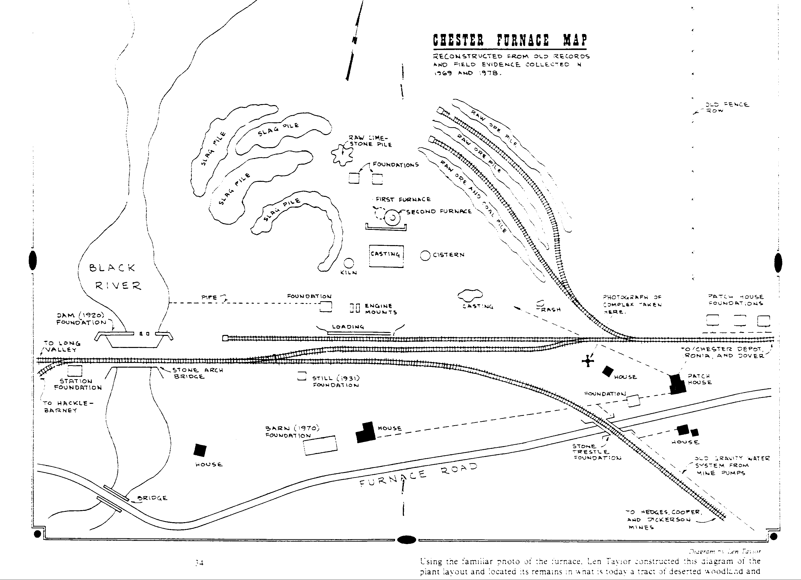
This map of the Chester Furnace site was created by Len Taylor and printed in “Chester’s Iron Heyday,” by Larry Lowenthal.

News & Views Preservation – Information – Education Page 3

DON’T MISS IT!

Len Taylor has kindly offered to lead a tour of the Chester Furnace site for CHS members and friends. On Saturday, May 17th, we will meet at 10:00 AM at the Township Garage on Furnace Road. Len’s knowledge of the area and Chester’s history will make this an event that shouldn’t be missed. We hope to see you there! If you are unable to make it, the county also sponsors a tour of this site and many other Morris County locations. Tour brochures are available at Fosterfields and from the Parks Commission. They’ll also available at The Cooper Mill when it opens for the season.

…First Congregational Church, continued from page 1

These men were not only strong Congregationalists, but were hard working farmers as well. Because these early comers were few in number, they joined with church members in Ralston and Mendham and all worshipped together in a log meeting house, which they erected in the Roxiticus area. The Congregationalists of Black River became more and more “homesick” for their own doctrines and form of worship, and in 1740 organized the first Congregational church. By 1747 they were able to erect their own meetinghouse. It was a commodious house of worship, with pews and galleries to seat 400. The furnishings of the church at Roxiticus were given to this new church. Hymns were sung from memory or, because few could read, the leader spoke a line or two, which the congregation sang back. This was called lining out the hymns.
The first site of the church was described as being across Hillside Road from the cemetery northwest of the present church, and was used for 63 years. Reverend Samuel Swayze, Jr. was the first pastor of this church. He was installed in 1753 and served for about 20 years. In 1773, he led a group of 72 families from Black River to an area fourteen miles south of Natchez, Mississippi.
~ ~ ~
The following is taken from a booklet entitled, “The History of the First Congregational Church of Chester, New Jersey," published in 1934 by The Conover Press.
“About the time of the building of this first church the excitement which caused the separation in the Congregational Churches of Connecticut and Long Island reached this settlement and a majority of the inhabitants became ‘Separates,’ as they were then called. A Separate Congregational Church was gathered which was ministered unto by Rev. Samuel Sweazy. He was the first settled pastor. He labored with the church for twenty years and then organized a colony, largely from Chester, and located near Natchez, Mississippi. Soon after arriving in their wilderness home they were regularly organized into a Congregational Church and Mr. Sweazy took its pastorate. Of
this, Reverend F. A. Johnson writes, ‘He was beyond doubt the first Protestant minister that ever settled in what is now the state of Mississippi, and his church as the first Protestant Church ever organized there. Therefore the Chester Church may be said to be the Mother of Protestantism and Congregationalism in the great Southwest.’
These Separatists retained the doctrines and form of government of the regular Congregational Churches. Their separation was a protest against the oppression and worldly influence of the union between Church and State which existed, especially in Connecticut. All honor to the spirit of being oppressed.”
~ ~ ~

Before 1799, Black River was still part of Roxbury, but decided to break away and formed Chester Township. In 1803, the Congregationalists replaced their original house of worship with a new church (2nd building), which was built in the area that is now the center of the cemetery.
It was described as more modern in appearance, fifty feet long by forty feet wide, with front and side galleries, a steeple and a bell (The first bell in the area!). Then in 1856 a meeting was held to determine by vote where a new church building (the present church) should be erected. It was built for $5,000, a small sum in comparison with the construction costs of today. The chandelier was a gift from the First Congregational Church of Newark.
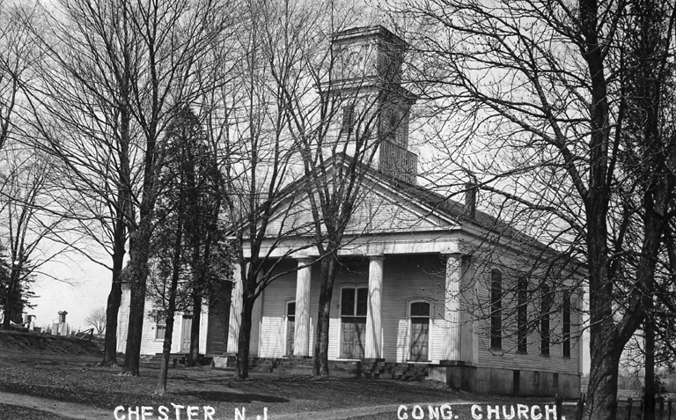
This picture of the church dates to the early 1900’s.

See First Congregational Church, page 5…

See First Congregational Church, page 5…

News & Views Preservation – Information – Education Page 4

…First Congregational Church, continued from page 4

In 1876 it was decided that for Sabbath School and for weekly meetings, a chapel needed to be built. The total cost for the chapel was $1,098.21!
The interior of the First Congregational Church is one of perhaps two remaining examples of “trompe l’oeil” decoration in the state. M. A. Murdolo restored the beautiful decoration in 1986. Mundolo discovered this design under many layers of work, as he was preparing the walls for restoration. It was by far the most beautiful he had seen, and it is this original design that you see today. The detail and the design, especially the ceiling, have amazed many.
The decorated tracker organ (Opus 128), built by J. H. and C. S. Odell in 1873, is still used for regular services and was restored in 2004 by Meloni & Farrier Organ builders of Port Chester, New York. Its original cost, including freight, was about $1,800 and according to the people who repaired our organ, there is only one other like it in operation today. They say it is priceless today! The “horse sheds” or carriage houses behind the church are probably the only remaining ones associated with a church, this side of the Mississippi. The sanctuary building is listed on the National Register of Historic Places.

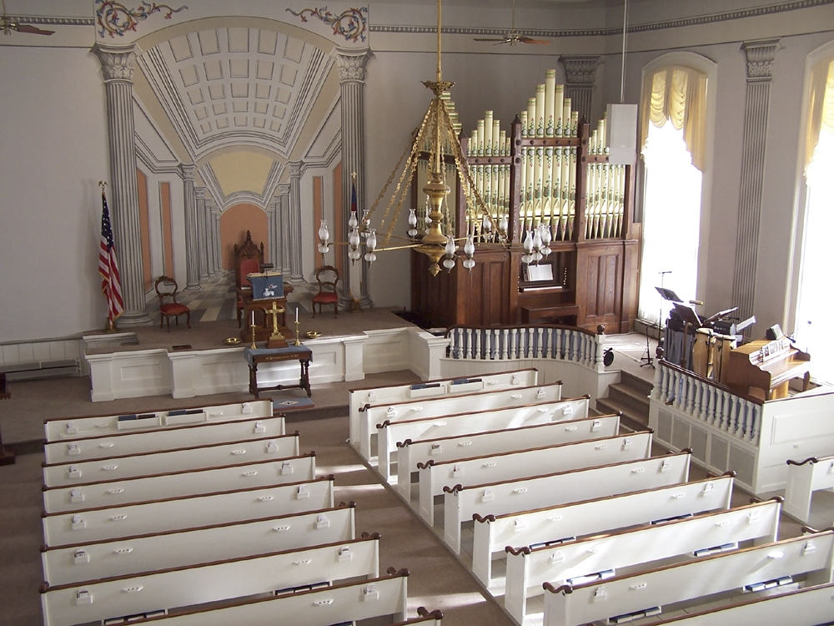
The beauty of the organ and the "Trompe l'oeil decoration combine to create an amazing site. Photo by Joan Case.

Many periods of renovation have taken place since 1856, but by and large, the building remains
the same to the eye. The installation of electricity brought the most notable change. The kerosene lamps that once hung from the ceiling are gone, as are those that were in the chandelier and those that lit the organ. The iron “eye” into which the hanger for the lamps was placed is still in the organ. The once hand-pumped pipe organ has been electrified. The Pulpit appointments and Communion Table were installed in the 1880s. Overall, the work from past and the changes of the present combine to make the First Congregational Church of Chester one of the town’s many beautiful structures, and one all should take time to see.
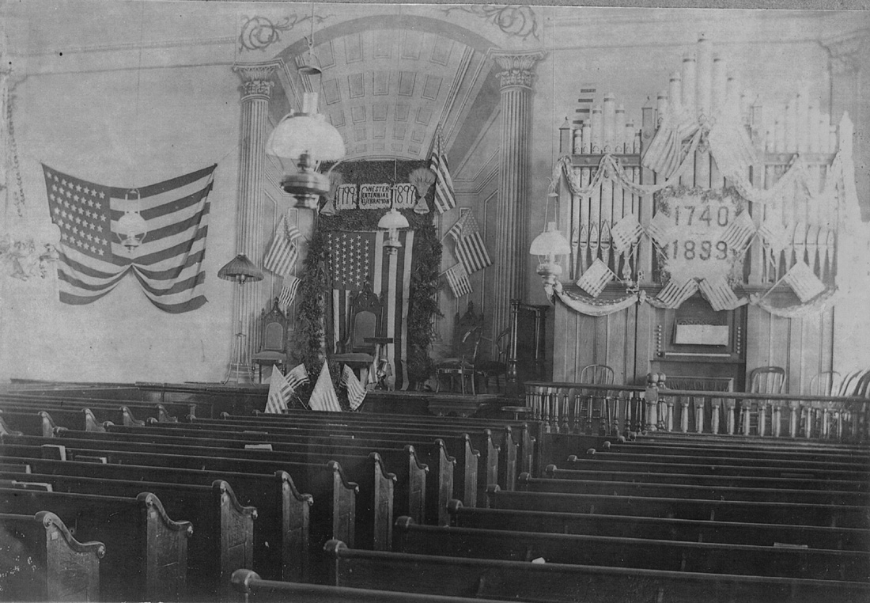 The Interior of the church as seen in 1899 for Chester’s Centennial Celebration.

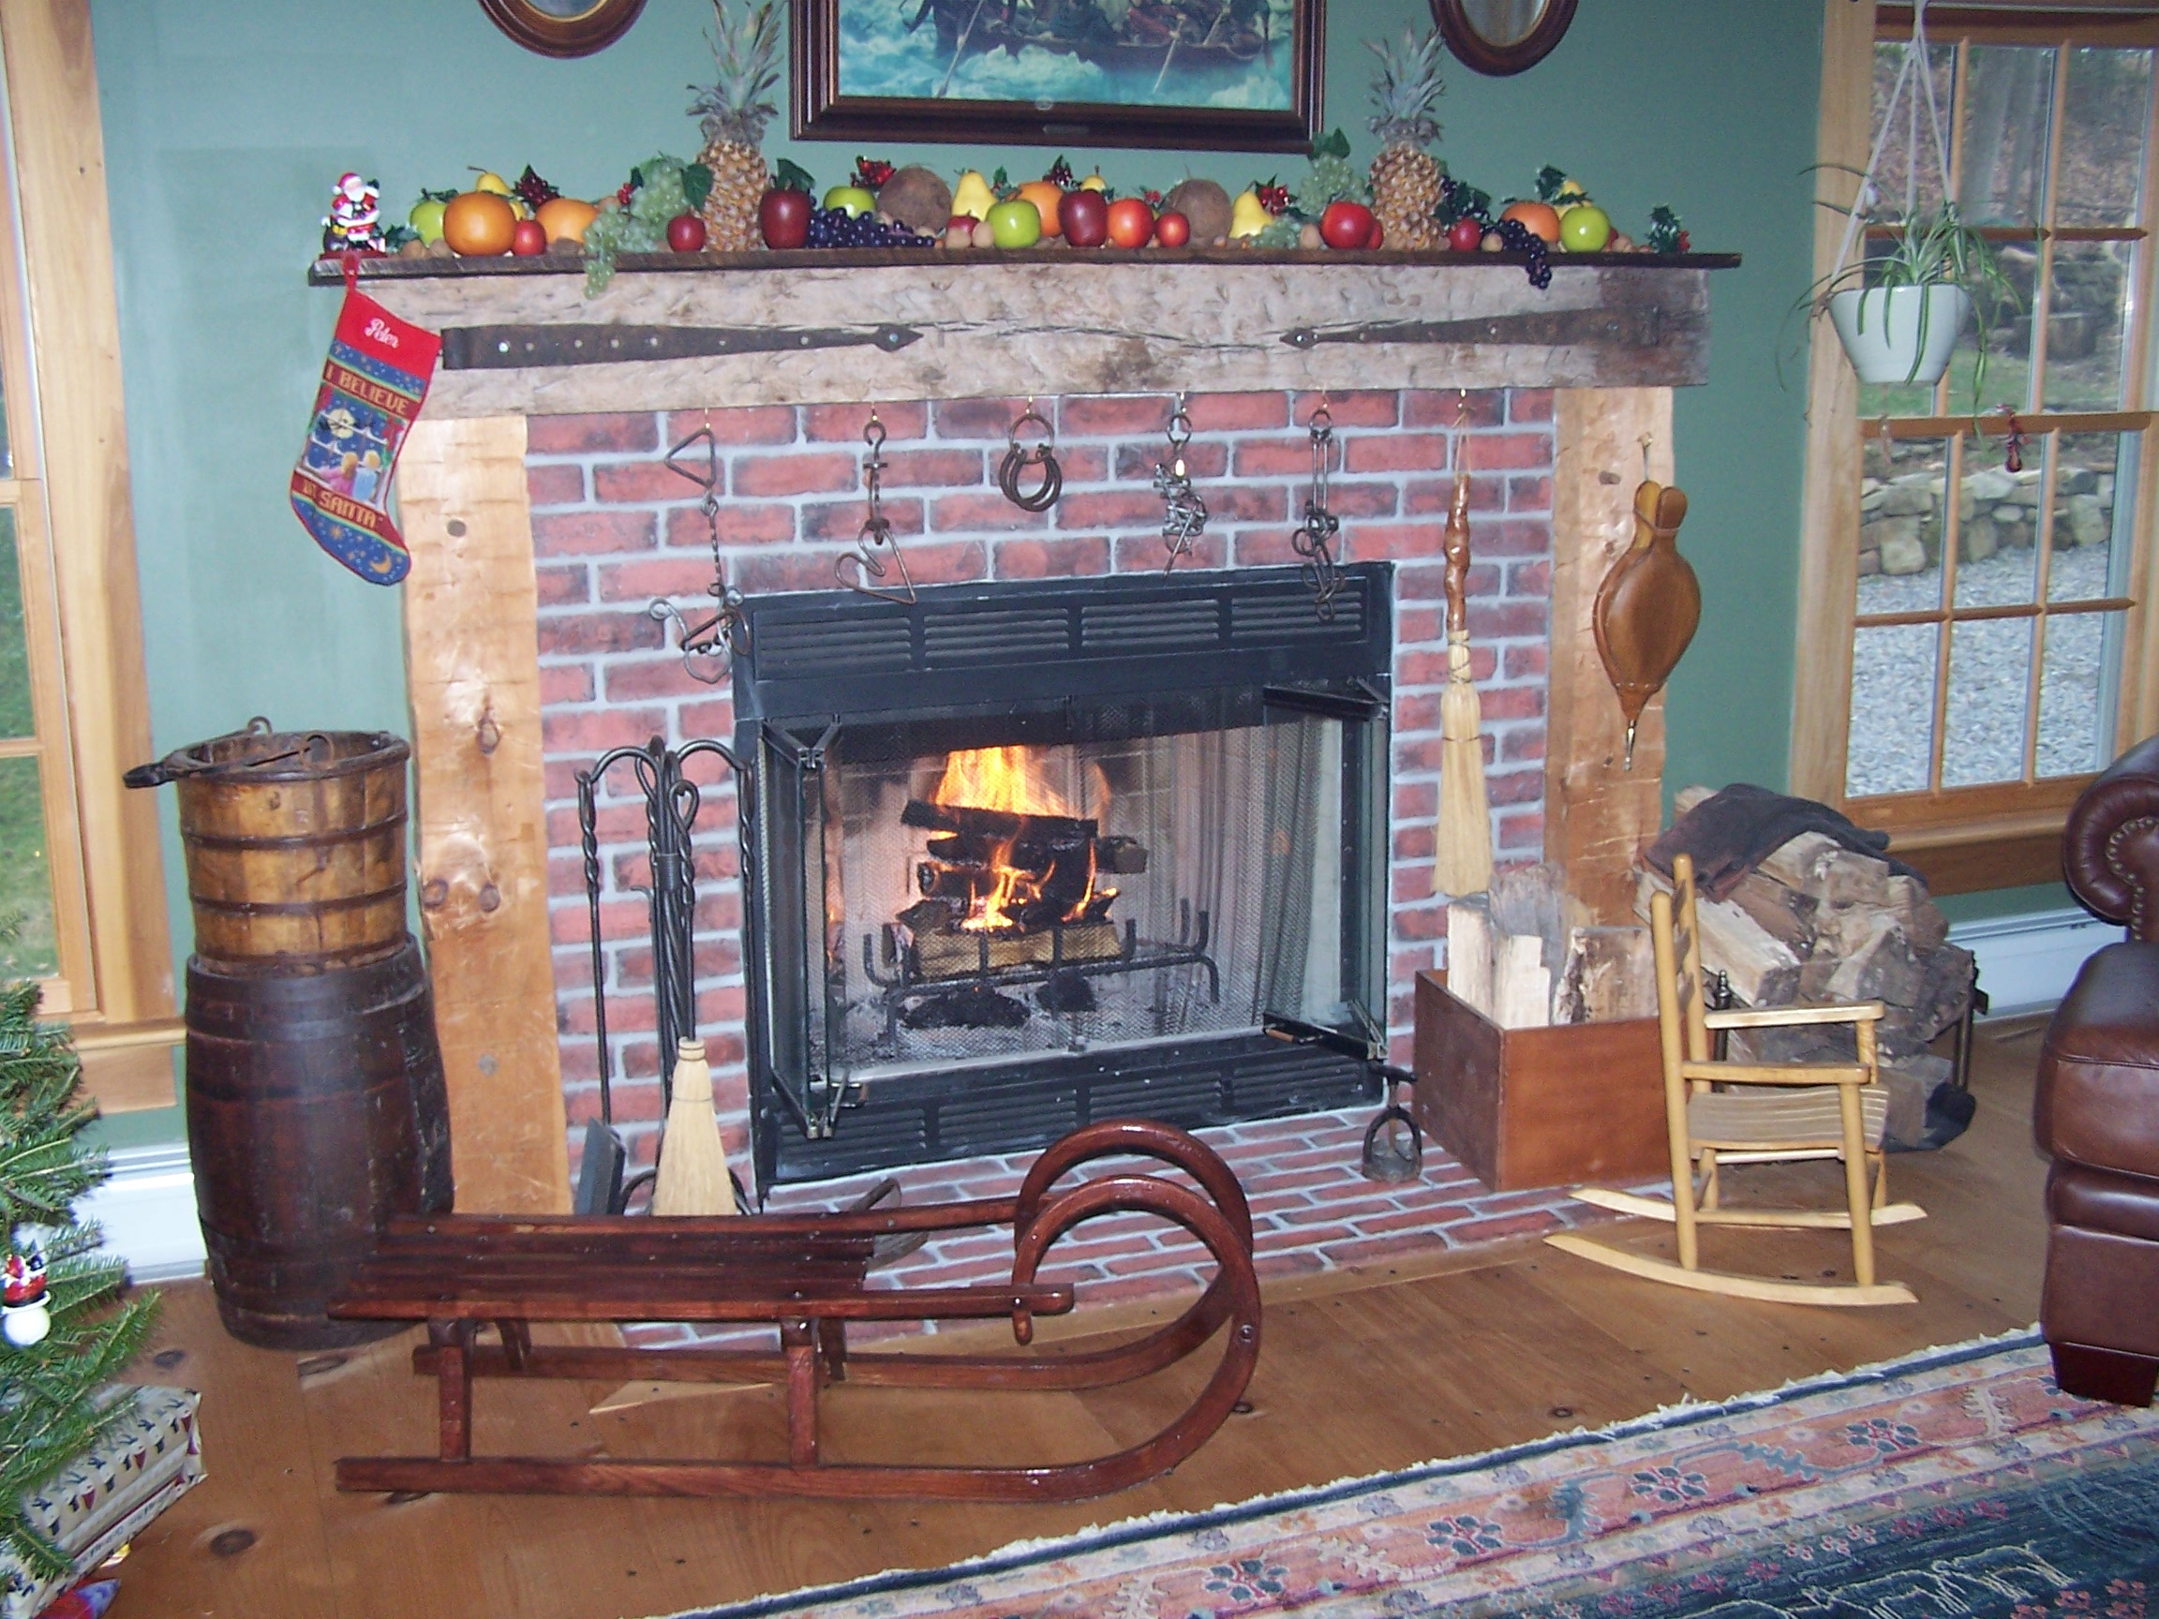

News & Views Preservation – Information – Education Page 5

CALLING ALL MEMBERS!

The Chester Food Pantry needs our help! Please help us to help those in need of assistance.

The following items are much needed:

Toilet tissue
Canned Fruit
Food Items such Hamburger Helper

Reminder—The Food Pantry’s drop- off areas are in the foyer of the Chester Library and in the exit area of Shop Rite. The box in the Chester Post Office is for the Morristown Pantry.

Many thanks,
Lois Taylor

News & Views Preservation – Information – Education Page 6
Morris County Park Commission Offers Something For Everyone

Whether it’s hiking, plant life, history or a combination of these things you are interested in, the Morris County Parks Commission offers something for everyone. Visits to the Cooper Mill, Foster Fields, and Historic Speedwell are just the beginning. It’s worth taking a look at the \website (http://www.morrisparks.net) of the Parks Commission to obtain the calendar of the events offered at various locations. Brochures are also available at these sites. Visits to the Great Swamp, the Frelinghuysen Arboretum or the Kay Environmental Center offers many possibilities.
Our own Cooper Mill opens for the season on May 3, 2008. Here’s a look at the activities that will start off the season:

Saturday, May 3, 2008
10:00 am -3:30 pm
Opening Day Extravaganza!
The Cooper mill celebrates the start of its 29th season. Watch as our miller sets up the grindstone and begins grinding flour.

Saturday, May 17, 2008
11:00 am-4:00 pm
Born to Be Shorn
See how sheep are shorn and help with skirting, washing, carding, spinning, and weaving the fleece. See newborn lambs.

Sunday, May 11, 2008
1:00 pm-3:30 pm
1880s Mother's Day at Milltown
Try out the old fashioned way of doing chores such as washing clothes, ironing, rug beating, sewing, and mending. A free bag of flour or cornmeal will be given to all Moms, while supplies last.

Sunday, May 25, 2008
1:00 pm-4:00 pm
Memorial Day Picnic
Bring your own picnic lunch and blanket and sit outside by the waterwheel. Enjoy participating in games that were popular 100 years ago.

Saturday, June 7, 2008
1:00 pm-4:00 pm
"Common Thread" Quilters
The Common Thread Quilters will demonstrate their craft and an exhibit of quilts will be displayed.

Sunday, June 15, 2008
1:00 pm-4:00 pm
Awesome Anvil Antics
Blacksmith Kevin Perry will be at work at Cooper Mill forging iron into works of art using 1900s techniques and tools. Free bag of flour or cornmeal will be given to all Dads while supplies last.

And at Fosterfields…

Wednesday, April 2, 2008
10:00 am-5:00 pm
Opening Day
Experience farm and domestic life during the early 20th century.

Saturday, April 5, 2008
10:15 am-11:15 am
"Explore the Farm" Wagon Ride
You learn a lot about Charles Foster’s farm and sustainable farming while enjoying a horse-drawn wagon ride Pre-registration is required. Please call 973-326-7645.

Saturday, April 5, 2008
3:00 pm-5:00 pm
"Voices of American Farm Women”
The traveling photographic exhibit, "Voices of American Farm Women" opens this day and will remain at Fosterfields for the month of April.

Sunday, April 13, 2008
1:00 pm-3:00 pm
Bee-ginning a Hive
The farm staff will establish a new bee hive, teach visitors basic facts about beekeeping, and explain how to keep a hive healthy.

This Can’t Be Beat!

On Satrday, April 26th from 1:00 PM – 5:00 PM, several local historical attractions will be open free charge! Fosterfields, Acorn Hall, the Schuyler-Hamilton House, Historic Speedwell, Macculloch Hall, the Morris Museum and Washington’s Headquarters will all participate. A free shuttle bus will be operating between locations. Call the Morris County Visitors Center for additional information at 973-631-5151.

News & Views Preservation – Information – Education Page 6
News & Views Preservation – Information – Education Page 7

CHS Archives
Carol Zaikowski, Chair

The Chester Historical Society thanks member Susan Persak, who is also the Library Director of the Chester Library, for applying on our behalf, and winning a grant from the Institute of Museum and Library Services.
We were selected to receive the IMLS “Connecting to Collections Bookshelf,” which is a collection of texts, DVD’s, charts, online resources, and other material that will be useful to us in caring for our historic collections. The Bookshelf will be placed in the History Room.

Thank you Sue, we very much appreciate it!!

As always, we continue to need help from all of our members in getting our archives in order, both in the Chester Library and in our storage area(s). Please call me at 876-9599 if you have some time to help out. Let’s make 2008 “The Year of The CHS Archives.” Let’s get it done so we can move on.

Editor’s Note: The Institute of Museum and Library Services instituted this award in response to a 2005 Heritage Preservation study that found our nation’s special collections, an important part of our history, are in great need of preservation. We are indeed fortunate to have access to these resources to help care for our collection. You can access the IMLS website, http://www.imls.gov, for more information.

Chester Historical Society’s

News & Views

P.O. Box 376, Chester, NJ 07930
(908) 879-2761
HistoricChester@gmail.com
This newsletter is published 4 times a year by the Chester Historical Society.
Editor: Cindy Murphy – (908) 879-1754
Distribution: Brian and Cindy Murphy

"Chester, New Jersey - A
Scrapbook of History"
A Book Review By Alison Dahl

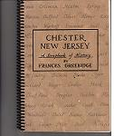

"Chester is filled with families who know nothing of the township's past," wrote Edwin Collis, who was known as Chester's most historically informed citizen. This, from the book's preface, plants a challenge to those who want to delve deeply into Chester's past.
Published in 1974, Frances Greenidge's compilation of widely gathered information and memories offers the reader an academic and yet personally engaging wealth of facts, quotes, references, and archival photographs, tracing Chester's history from the Precambrian period of geologic time to the formation of the Chester Historical Society in 1969.
"The Scrapbook" as it is known, is rich with anecdotes interspersed among somewhat dryer facts, woven chronologically and separated by chapters starting with "Before the Settlers" and ending with "Then" and "Now". It can serve as an overview to encourage deeper research into specific periods, personalities, and events, or as a page-at-a-time source of historical entertainment.
"Today is always both an end and a beginning," wrote Ms. Greenidge in 1971. "What tomorrow will bring will no one can say, but it is my hope that the present trend will continue, with fine young families choosing Chester as the place to raise their children -- in one of the attractive new homes, or in one of the many old ones so full of memories of Chester -- 'way back when.'"
This soft-cover publication can be purchased for $13.00 (plus postage if necessary) from the Chester Historical Society. It can also be found at local business establishments.

Chester

A Few Announcements…

We're looking for folks who've lived in Chester for quite some time who would like to share their memories of "the old days.” We can provide you with a list of prompting questions, or you can just comfortably relate your stories, using a tape recorder, for our "Oral Histories" collection. Please call Helen Jones at 908 879-5355 - we'd love to hear from you!

We have scheduled "A Stroll Through the Old Village of Chester" on Thursday, May 8th, at 7:00 p.m. We’ll meet at the First Congregational Church as our first point of interest. Please keep in mind that the tour will take about an hour, possibly longer if there is a good deal of discussion, and there will be little or no opportunity to sit down. We’ll be on the go!

The CHS holds Trustee meetings on the first Wednesday of each month, at 7:00 p.m. in the Larison Room of the Chester Library. These meetings are open to all members of the CHS and we encourage you to attend. We welcome ideas and suggestions, and of course we are ALWAYS looking for participation from the general membership.

Historical
Society

Elected to Board of Trustees
Carol Zaikowski……………………………..President
Pam Stevens…………………………..Vice President
Ed Ng Treasurer
Lois Taylor Corresponding Secretary
Elaine Hanington Recording Secretary
Helen Jones Member-at-Large
Dee Dilley Member-at-Large

Appointed To Board of Trustees

Matt Koppinger Architectural Preservation
Carol Zaikowski…………………………………Archives
Amanda Dean Membership
Helen Jones Oral History
Alison Dahl Programs
Marie Ruzicka Publications
Ed Hanington Borough Historian
Len Taylor………………………..Township Historian

Chester Historical Society
P.O. Box 376
Chester, NJ 07930

Winter 2008

